**TASK ON AUTOSCALING GROUPS**

**Introduction to Auto Scaling Groups (ASG)**

Auto Scaling Groups (ASG) in AWS help maintain the right number of Amazon EC2 instances to handle application load efficiently. They automatically scale resources **up** or **down** based on demand, ensuring high availability and cost optimization.

**Key Features of Auto Scaling Groups**

✅ **Automatic Scaling** → Adjusts the number of instances dynamically based on traffic.

✅ **Health Monitoring** → Replaces unhealthy instances automatically.

✅ **Load Balancing Integration** → Works with Elastic Load Balancer (ELB) for traffic distribution.

✅ **Multi-AZ Deployment** → Ensures high availability across multiple Availability Zones.

✅ **Cost Optimization** → Uses Spot Instances and Reserved Instances for savings.

**How Auto Scaling Works**

1. **Define Scaling Policies** → Set rules based on CPU utilization, request count, or custom metrics.
2. **Specify Min/Max Instances** → Ensures the group never drops below or exceeds defined limits.
3. **Monitor Instance Health** → Automatically replaces failed instances.
4. **Distribute Traffic** → Works with ELB to balance incoming requests.

**Example Use Case**

* **Web Applications** → Scale EC2 instances based on user traffic.
* **Batch Processing** → Increase compute power during peak workloads.
* **High Availability Services** → Ensure redundancy across multiple regions.

1) Create one vpc in N.virginia region

Login to Amazon AWS console using your credentials.

Select Region as N.Virginia

Type VPC in Search box.

Go to VPC Dashboard

Click on Create VPC

Enter VPC name : ASG-vpc

Enter CIDR value : 12.0.0.0/16

Click on Create VPC

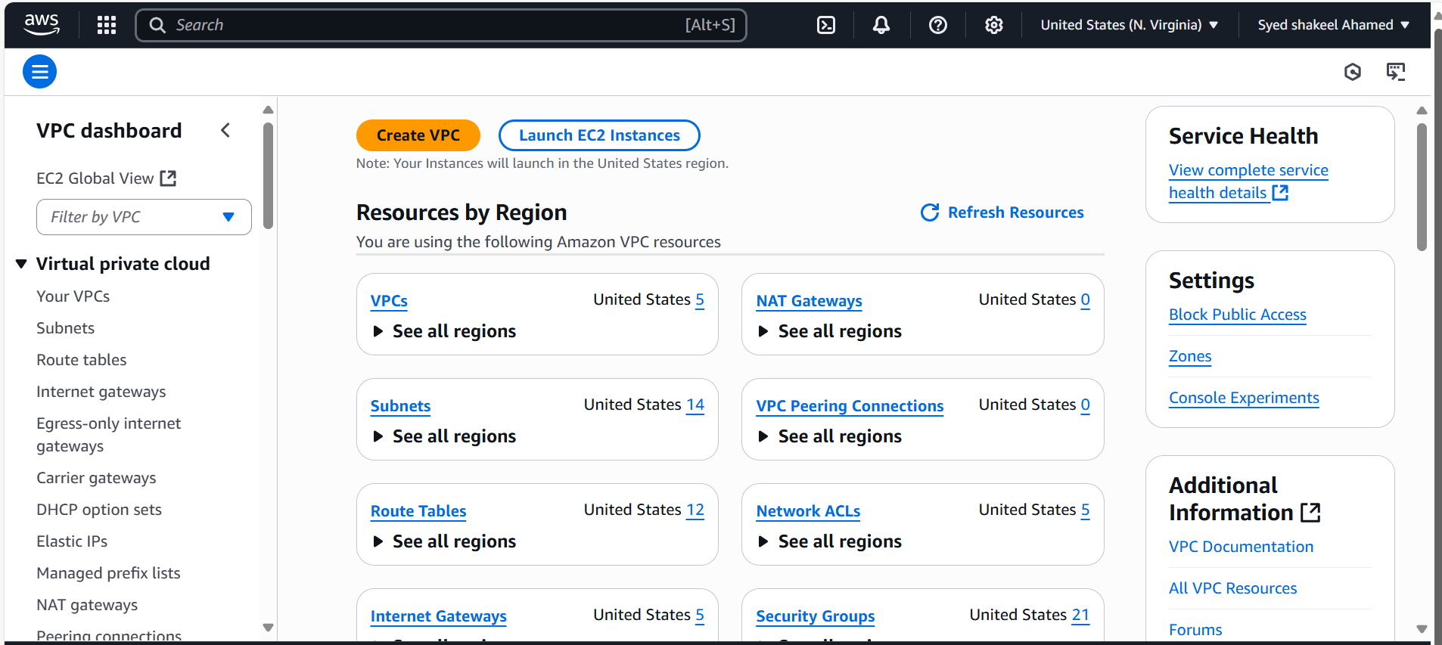

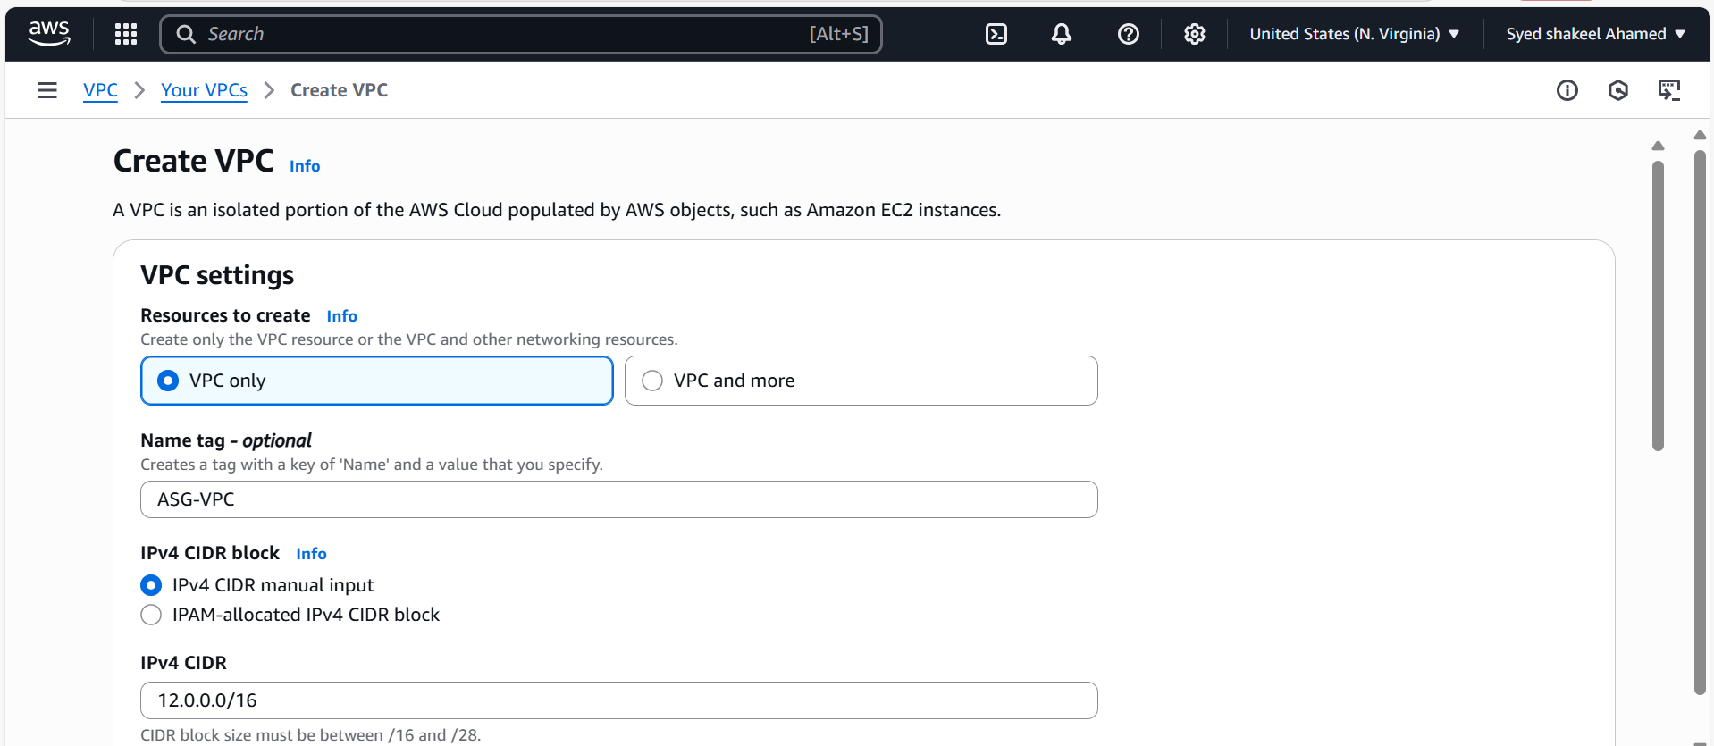

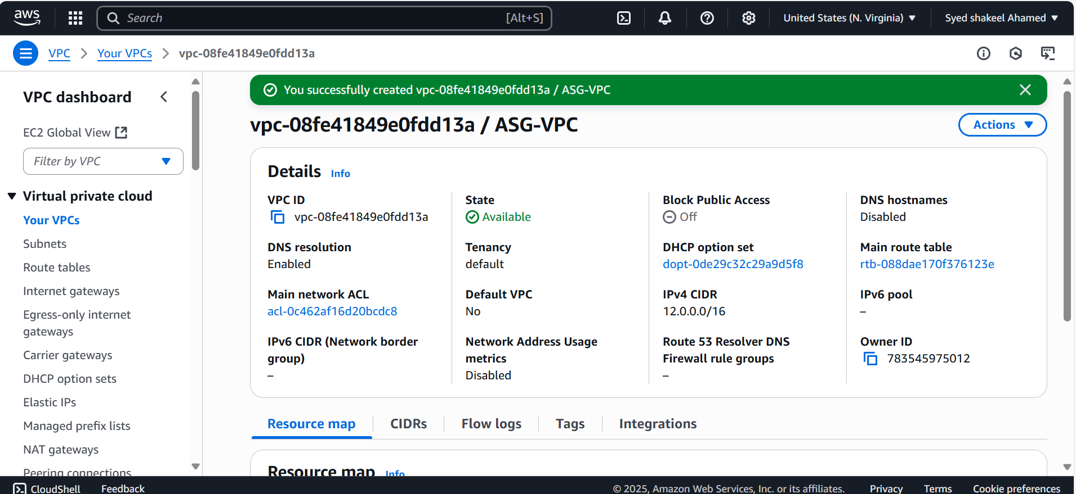

2) Create two subnets. One Public subnet and one private subnet

Login to AWS console using your login credentials.

Select N.Virgina Region

Select VPC and after creating VPC, Go to Panel in Left side select Subnets.

Click on Create Subnet

Select VPC id which you created

Go to Subnet settings Enter Subnet name as Public Subnet and select Availability Zone

Enter Ipv4 subnet CIDR block as 12.0.1.0/24

Click on create subnet.

Now repeat the same steps for creating Private Subnet

Subnet name : Private subnet ASG

Select Different Availability Zone

Subnet CIDR range as 12.0.2.0/24

Click on Create Subnet

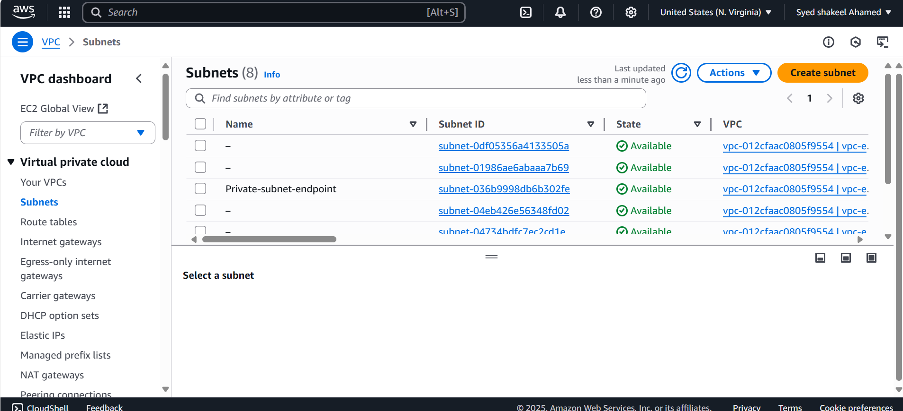

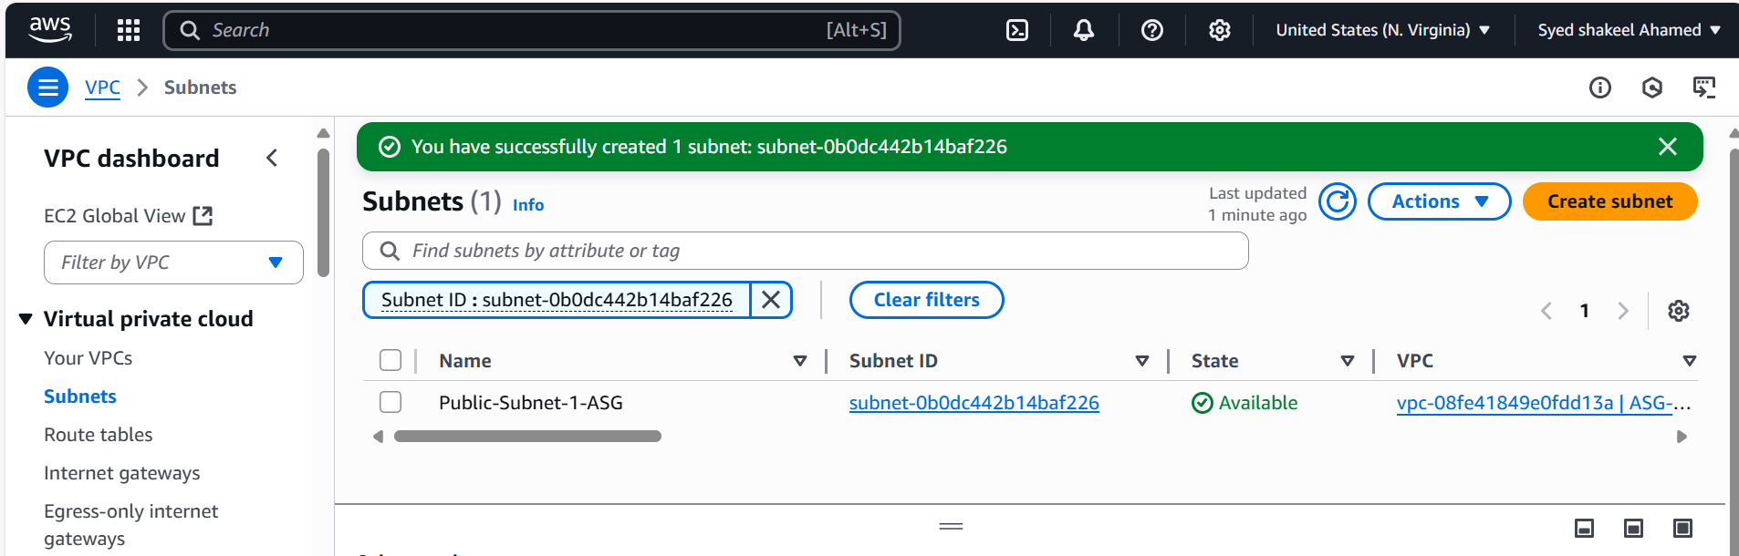

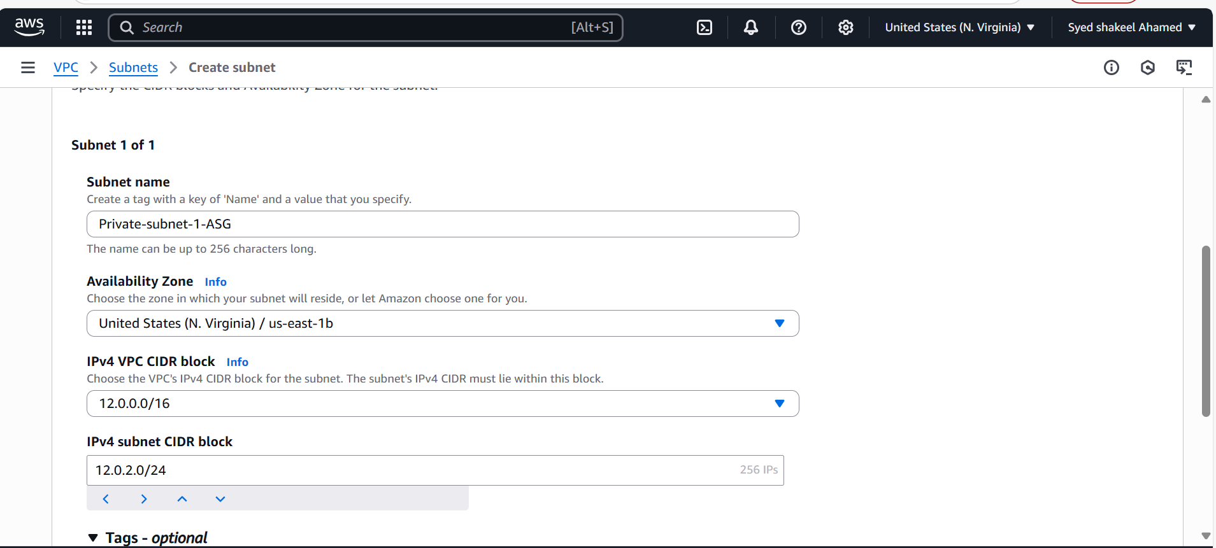

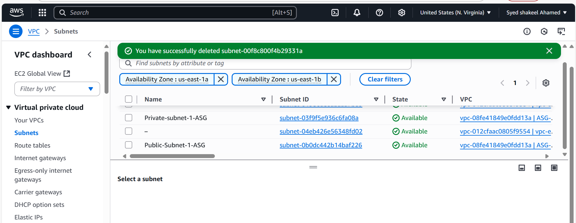

3) Provide the IGW to the vpc

After creating the VPC and Subnets, in VPC dashboard left panel, select Internet Gate way option

Click on Create internet Gateway

Enter the name of internet gateway- igw-ASG

Click on Create Internet Gateway

After successfully creating the internet gateway, Now attach it our VPC created

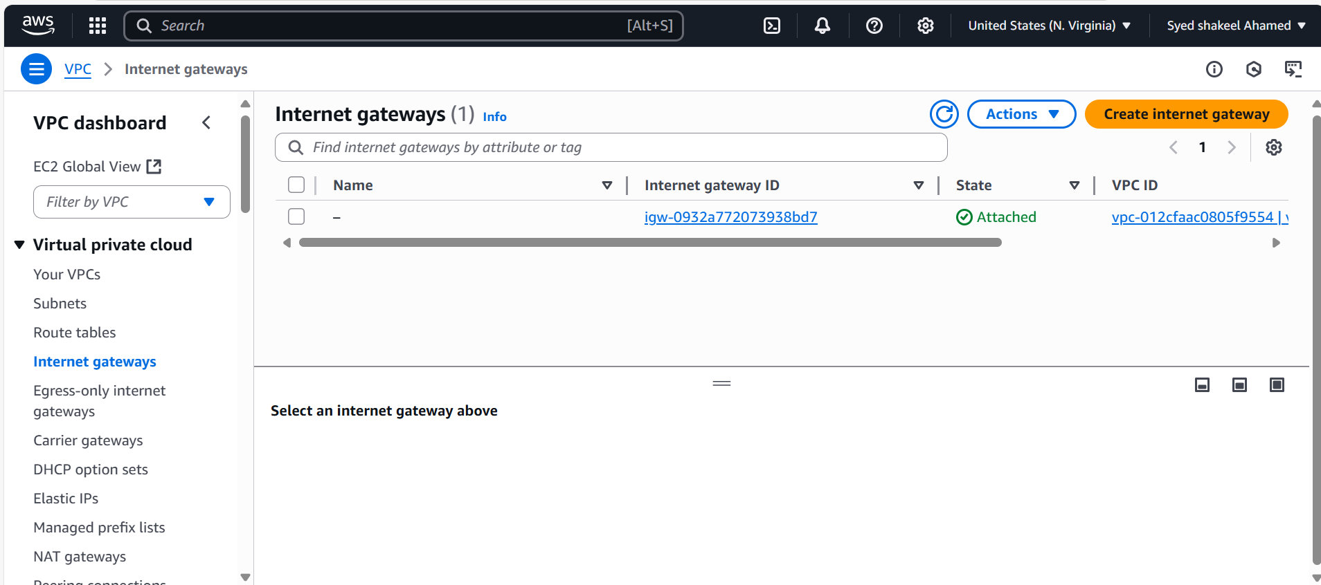

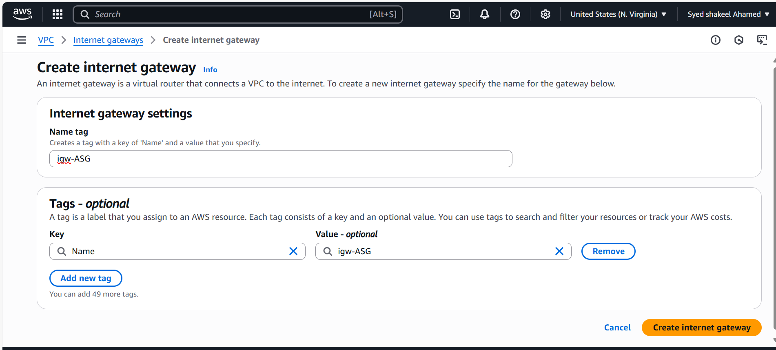

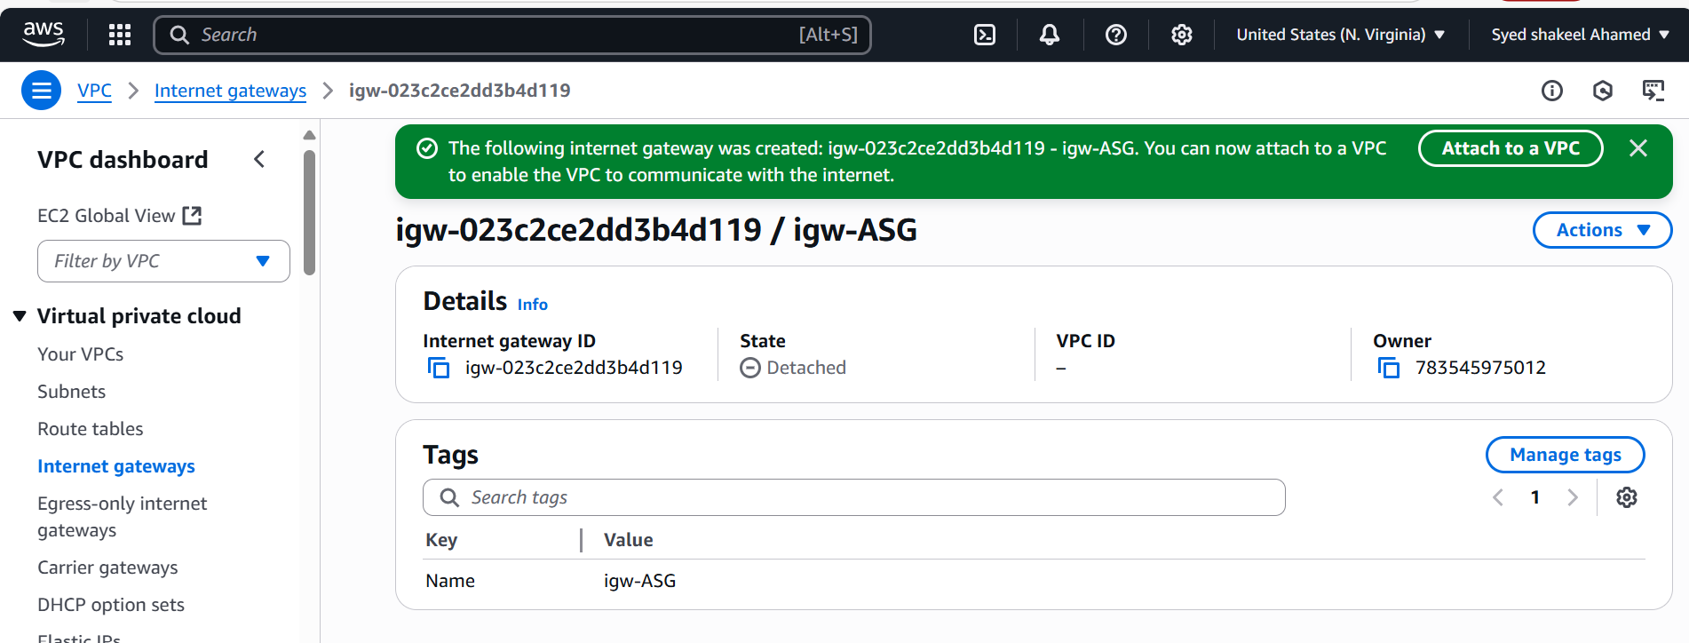

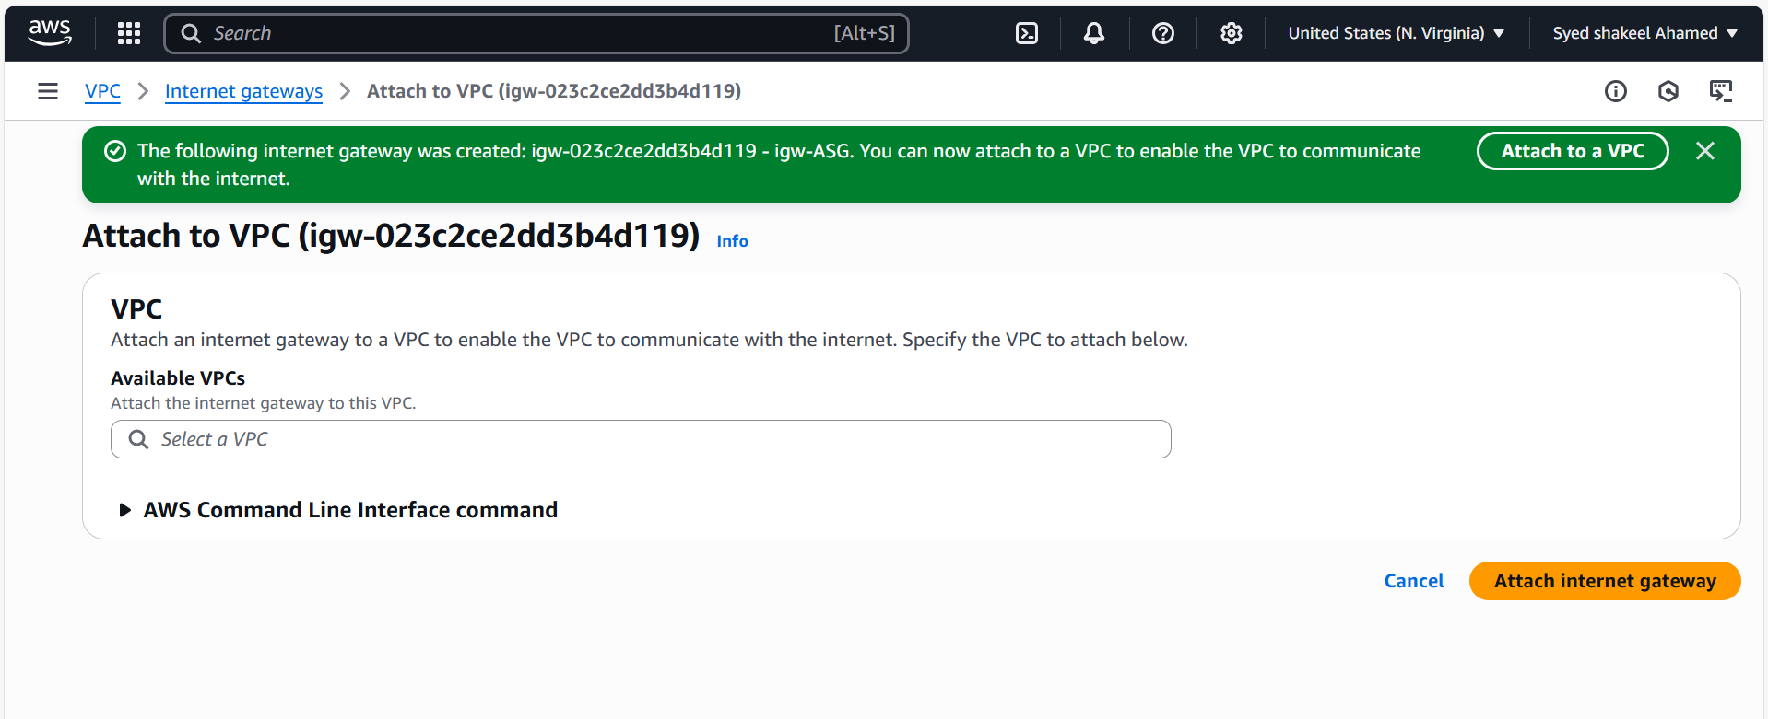

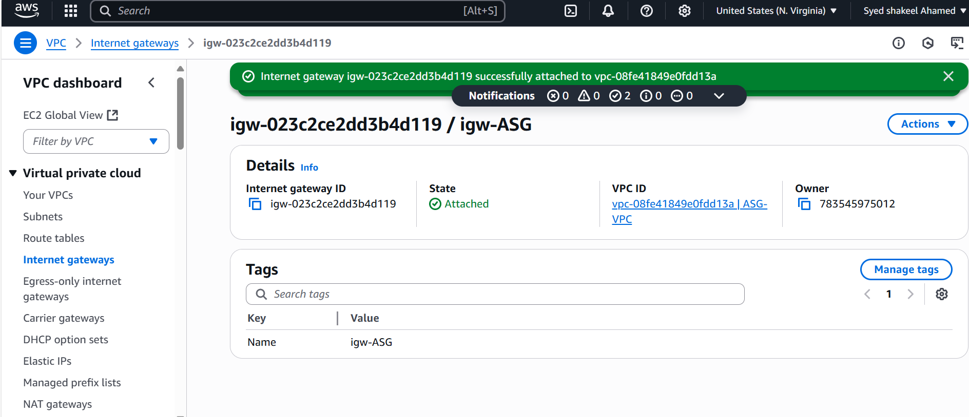

4) Create One public RT and one private RT

After successfully creating VPC,Subnets and Internet gateway, Now select the option Route tables in VPC dashboard.

Click on create Route Table.

To create Public RT

Enter the name as Public RT-ASG

Select the VPC to associate with this RT

Click on Create Route table.

Now go to the Subnet associations , Edit subnet associations, select Public subnet and save the changes.

Now go to Edit Routes and modify the route table with internet gateway which you created appropriate target and destination 0.0.0.0/0 and igw-ASG and save the changes.

Same steps repeat to create Private Route Table

Enter the name Private-RT-ASG

Select VPC associated

Click on create.

Next go to Subnet associations , select Private subnet and save the changes

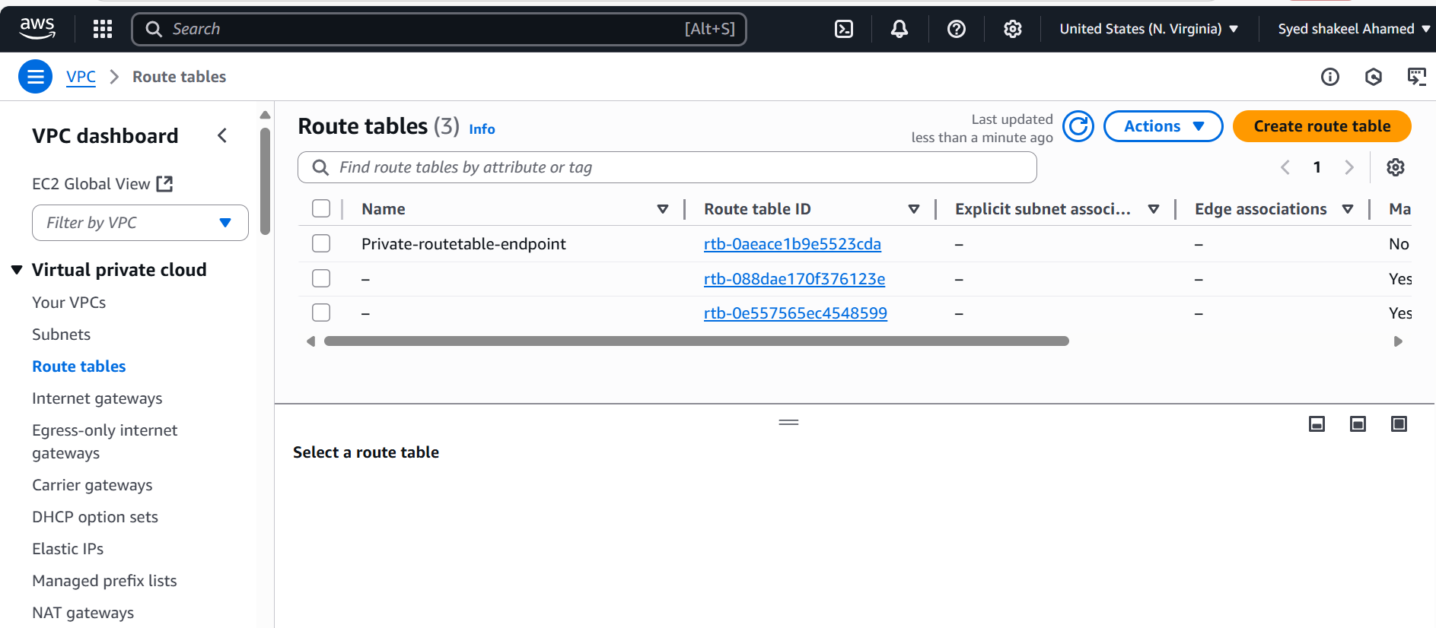

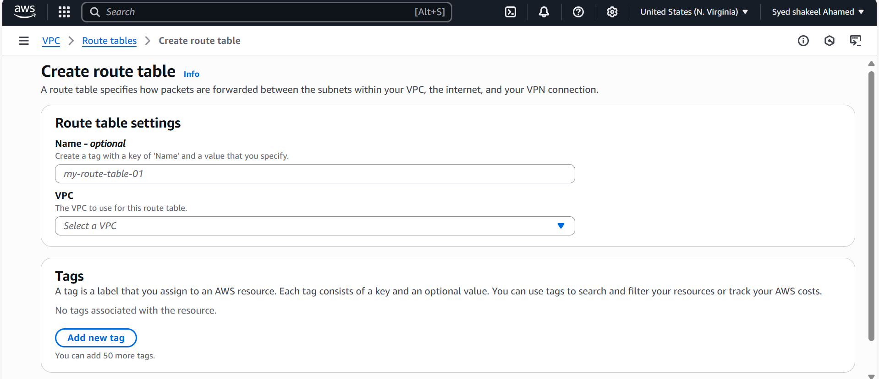

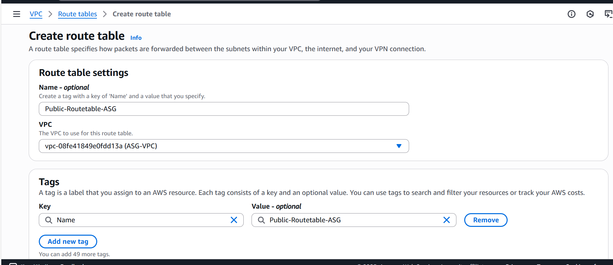

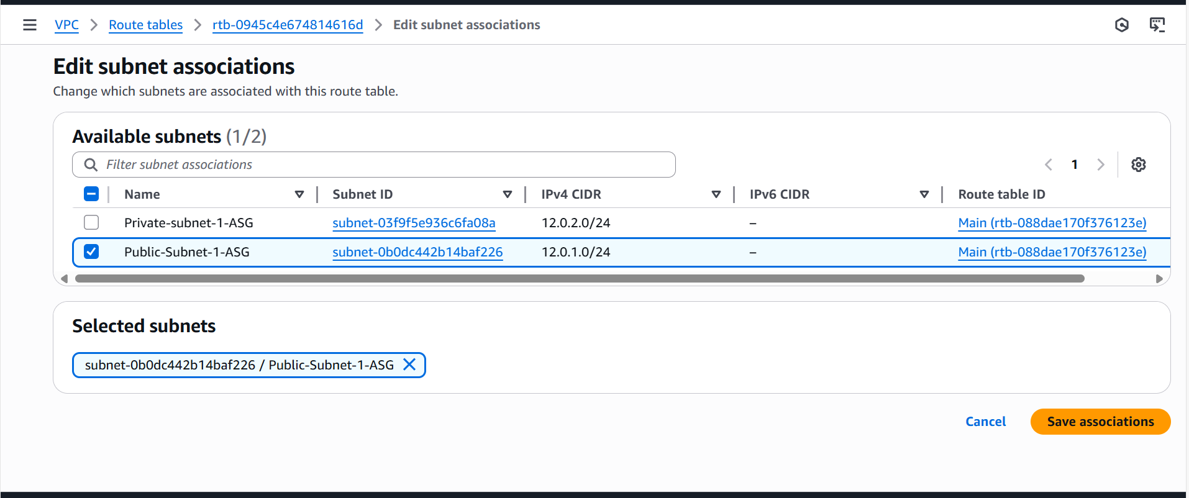

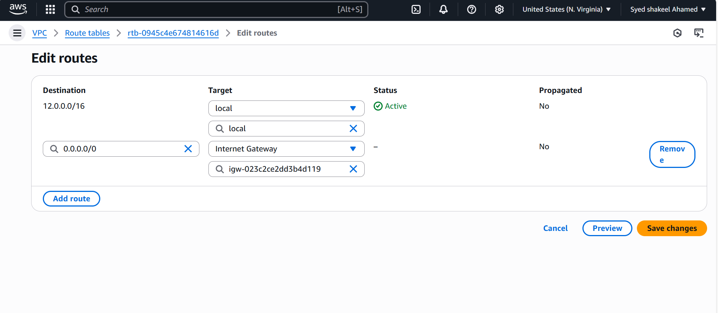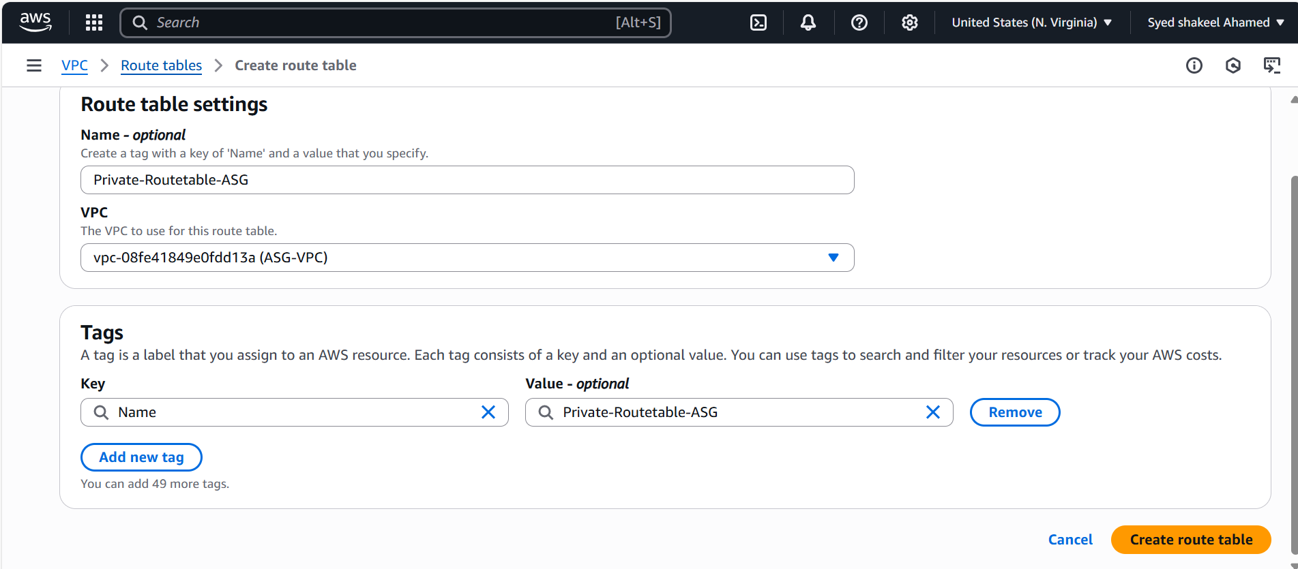

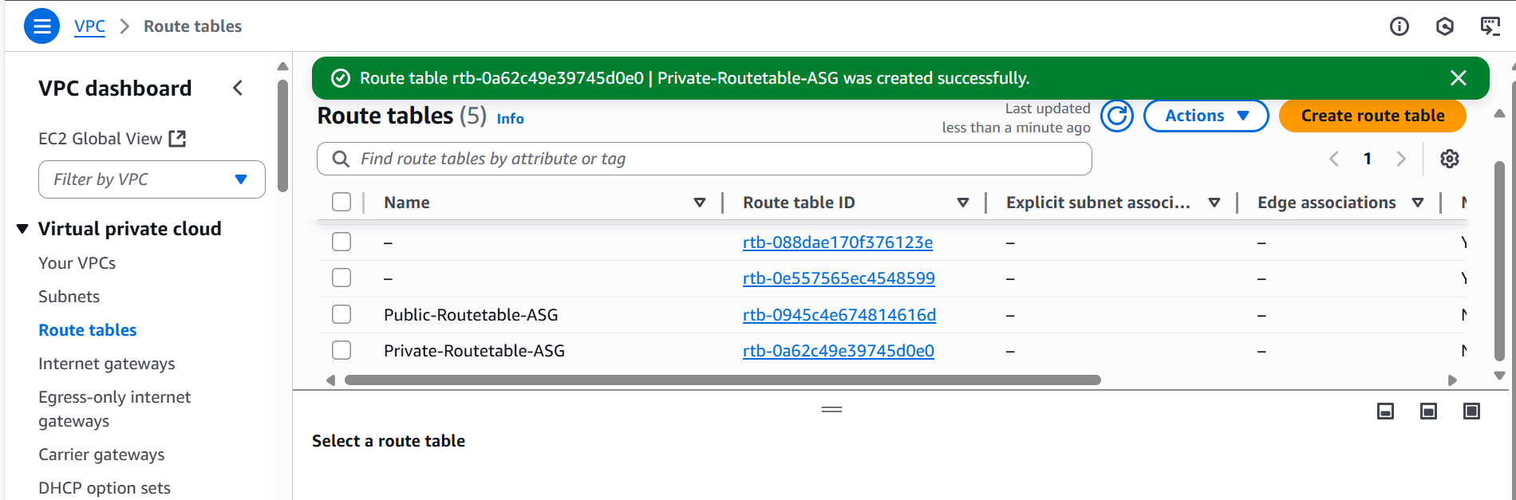

5) Deploy NAT gateway on public subnet and attach the NAT gateway to private subnet

After successfully creating the Route Tables, Select the option NAT gateway in VPC dashboard

Click on Create NAT Gateway

Enter the name of nat gateway as NAT-ASG

And deploy it in Public Subnet so select the Public subnet which you created

Connectivity Type: Public

Now Allocate one elasic IP to the NAT

Click on Create NAT Gateway.

Once the NAT Gateway successfully created, Now go to Private Route Table,Edit Routes attach NAT Gateway in Target and Destination preferably.

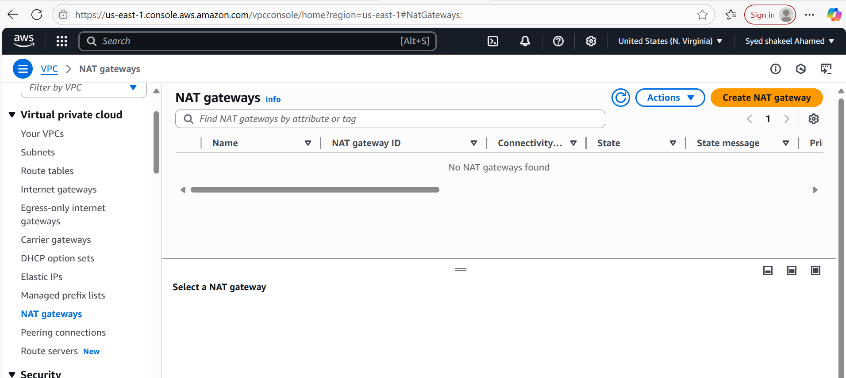

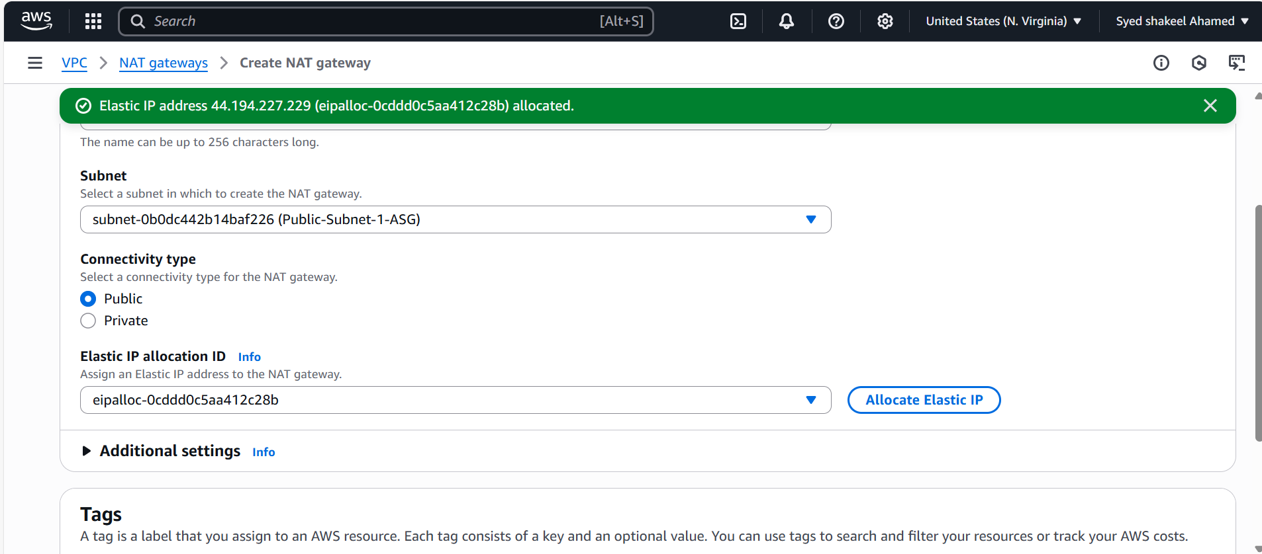

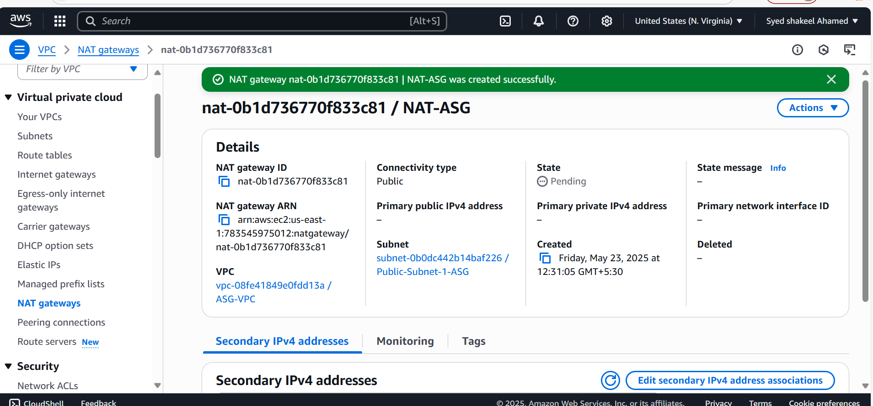

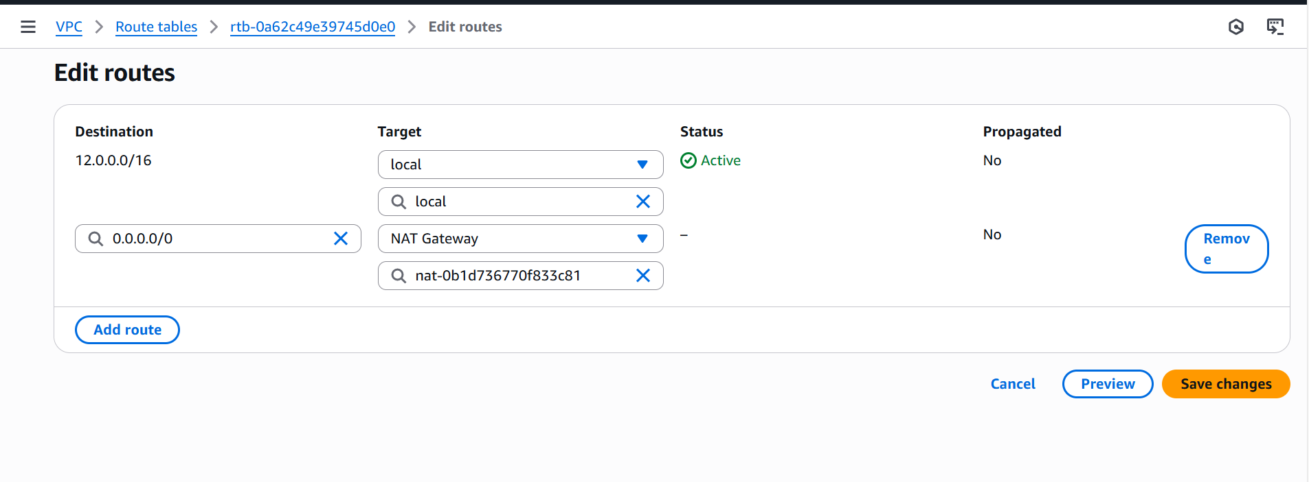

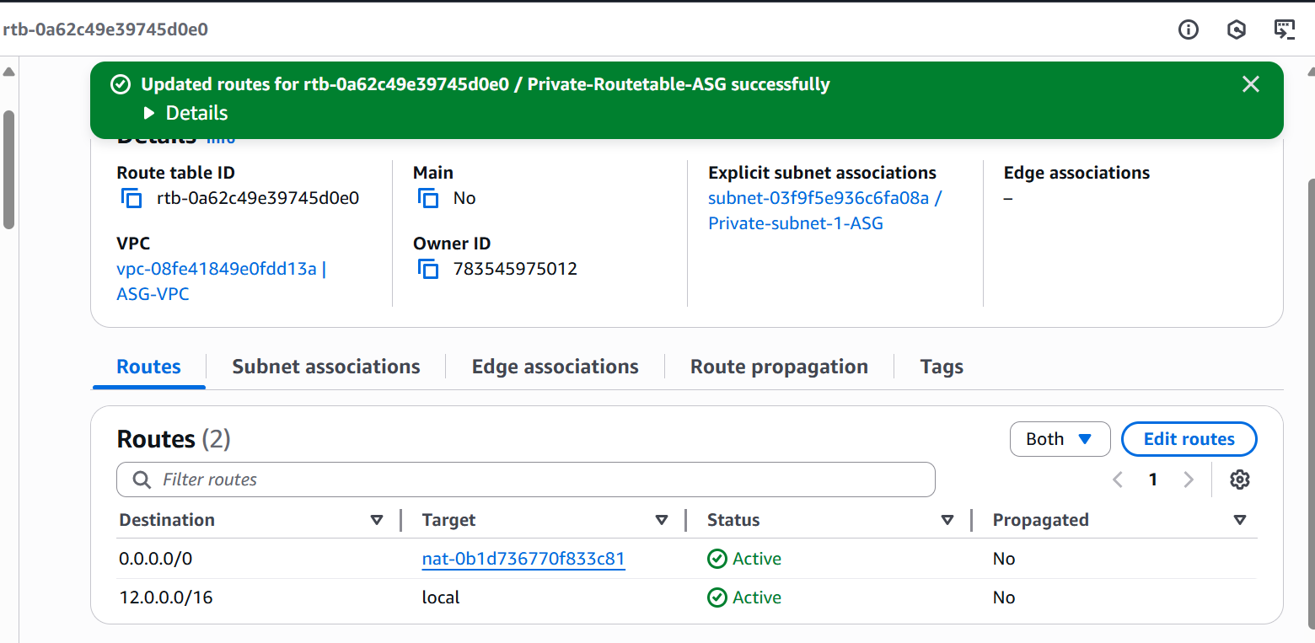

6) Create Two instances, one in public subnet and one in private subnet

Login to your AWS console with your login credentials.

After this search EC2 in Search bar

Click on EC2 and Go to EC2 dashboard.

Select Launch instance.

Enter the name of the instance ASG-Public-Server

Select the AMI-Amazon Linux2 image

Create the new Key Pair ASG.pem

In Network Settings, select the VPC which you created and also Subnet as Public Subnet-1a

And Enable Auto assign Public Ip as it is Public Server

Create Security Groups and provide inbound rules for SSH and All Traffic

Click on Launch Instance.

So instance will be provisioned successfully.

Repeat the same steps to Launch Private server and only change in subnet settings select Private subnet and do not enable the Auto assign Public ip and remaining everything will be same.

So Two instances of EC2 one is Public and another one is Private Launched successfully.

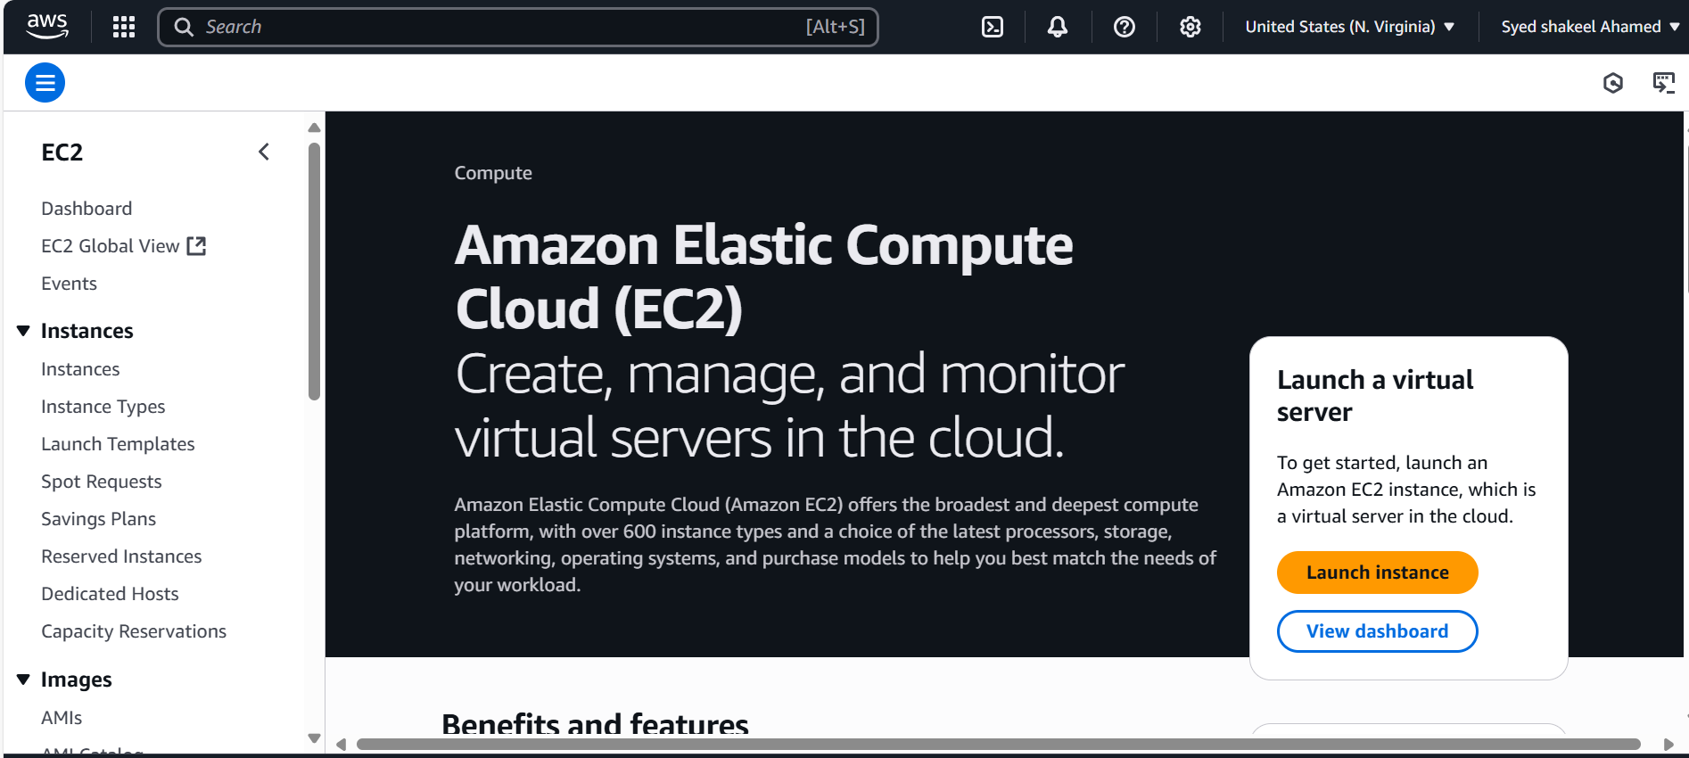

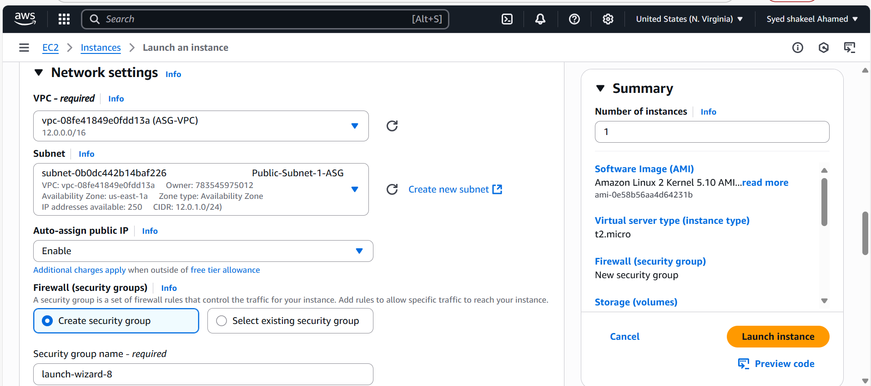

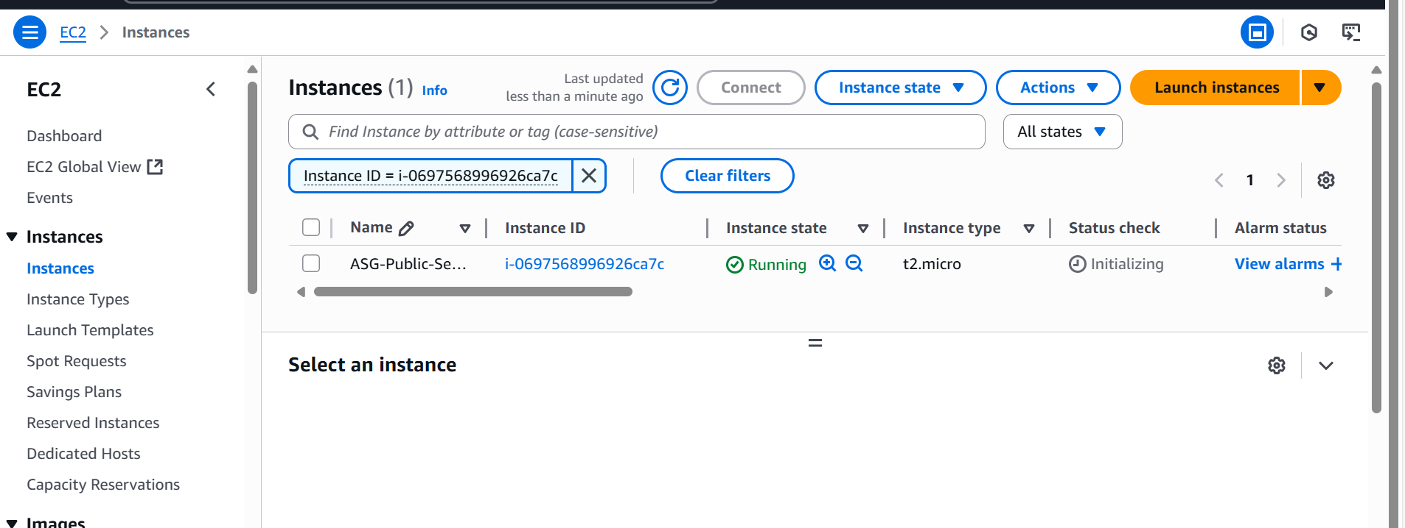

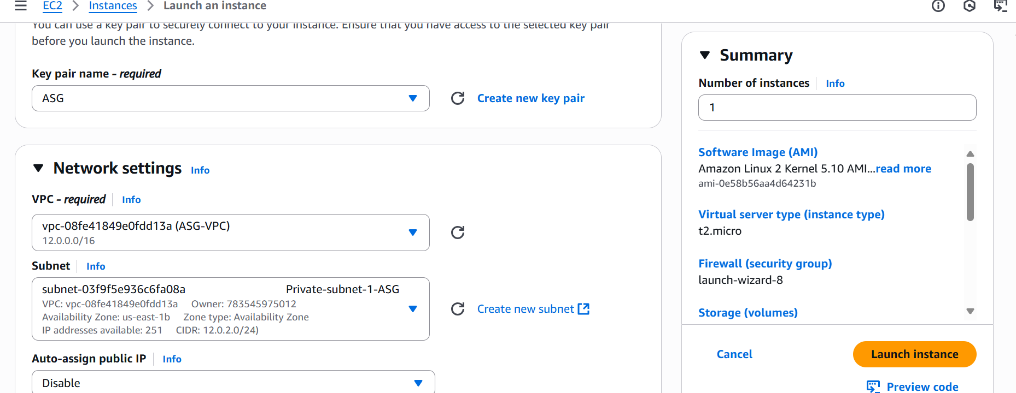

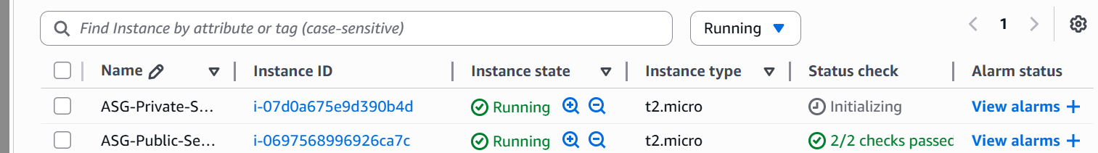

7) Deploy Apache server on both the ec2 instances with sample index.html file

To deploy Apache server (httpd ) in both the ec2 instances, I am going to select the USER Data option for Boot strapping .

Write a simple bash script in user data option.

#!/bin/bash

Sudo yum –y update

Sudo yum install httpd

Echo “Welcome to Public Server” >> /var/www/html/index.html

Sudo systemctl start httpd

Go to instance and Actions>Instance Settings>Edit User Data.

Stop the instance and Edit the user data with bash script

And restart the instance

Once the instance launched successfully, check with Public Ip:80 in the browser to verify Apache is working or not.

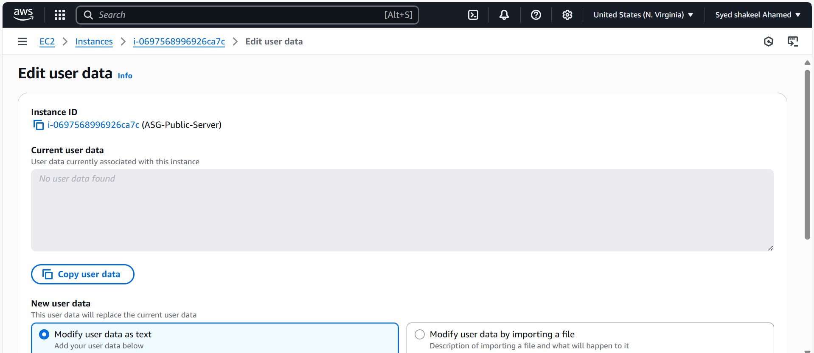

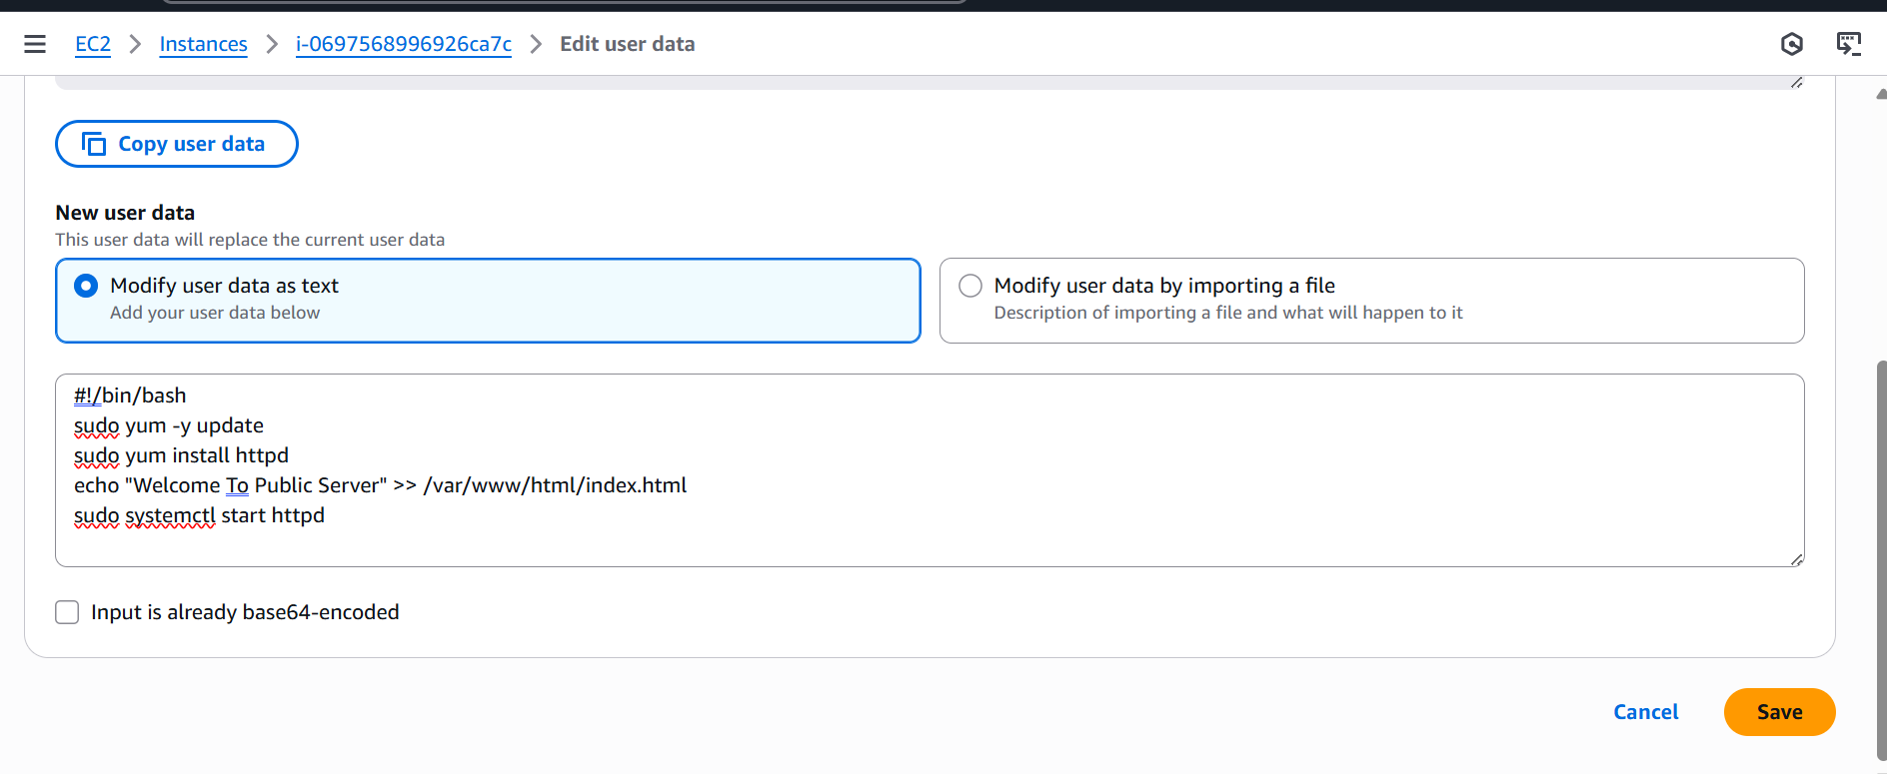

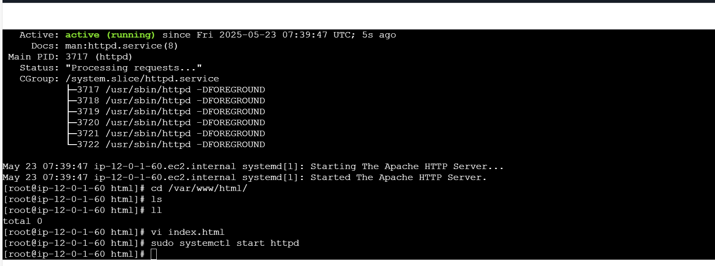

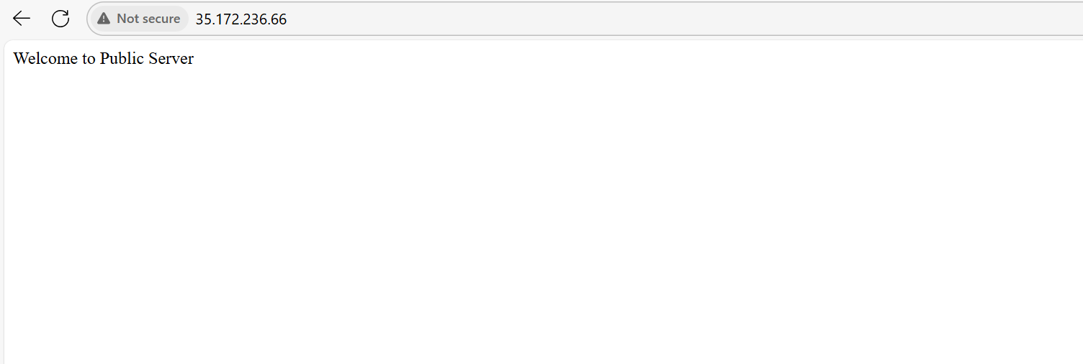

Private Server Apache installation

Copy the pem key used in Public server connection

Create the new pem key test.pem

Try to connect using Public server as Bastian server to Private server IP address

Now install the Apache in Private server

Sudo yum update –y

Sudo yum install httpd

Sudo systemctl start httpd

Sudo systemctl status httpd

After successful installation of Apache server

Try to access in the browser using Private Ip address, we will be unable to access due to Private server restriction access.

So now use curl http:Private ip:80/index.html

Create one sample index.html file

Copy that to deployment location of your Apache by providing the necessary permissions to deployment location using sudo chown ec2-user:ec2-user /var/www/html/

So once the deployment is successfully now try to access the Private ip address.

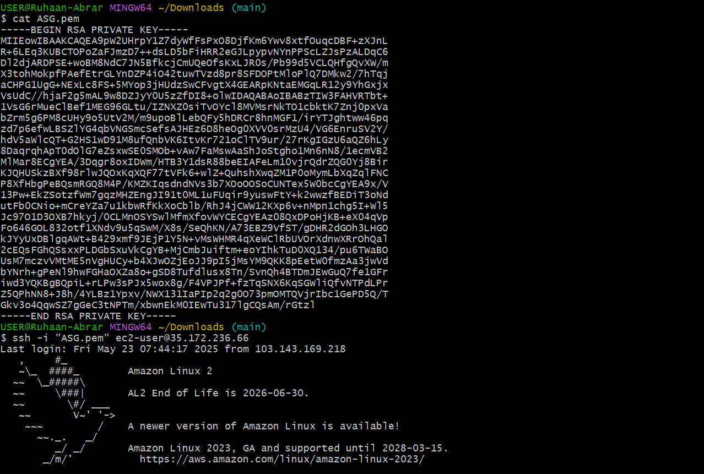

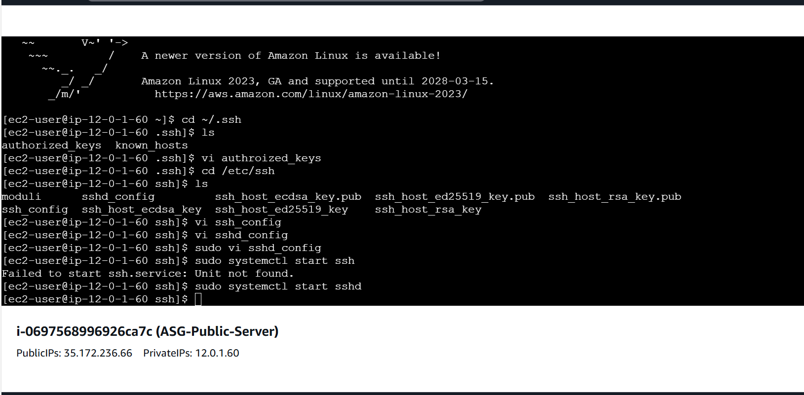

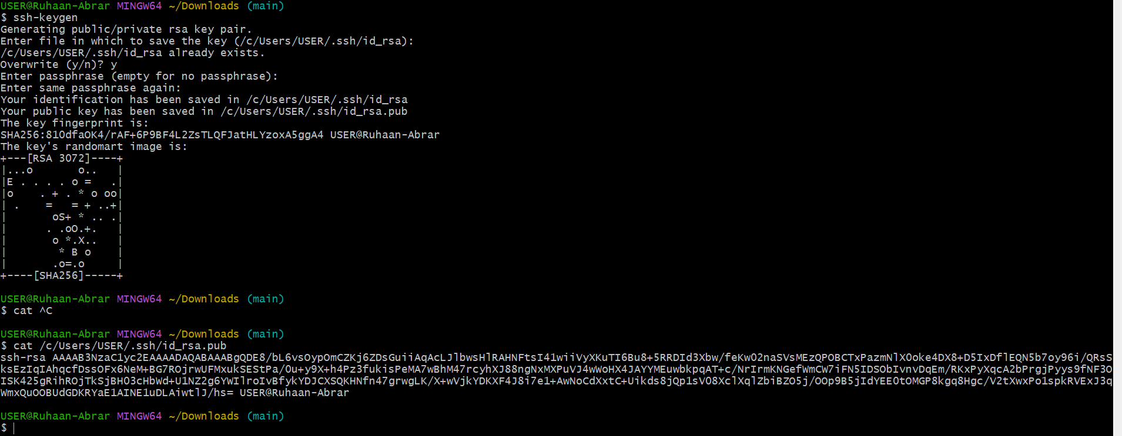

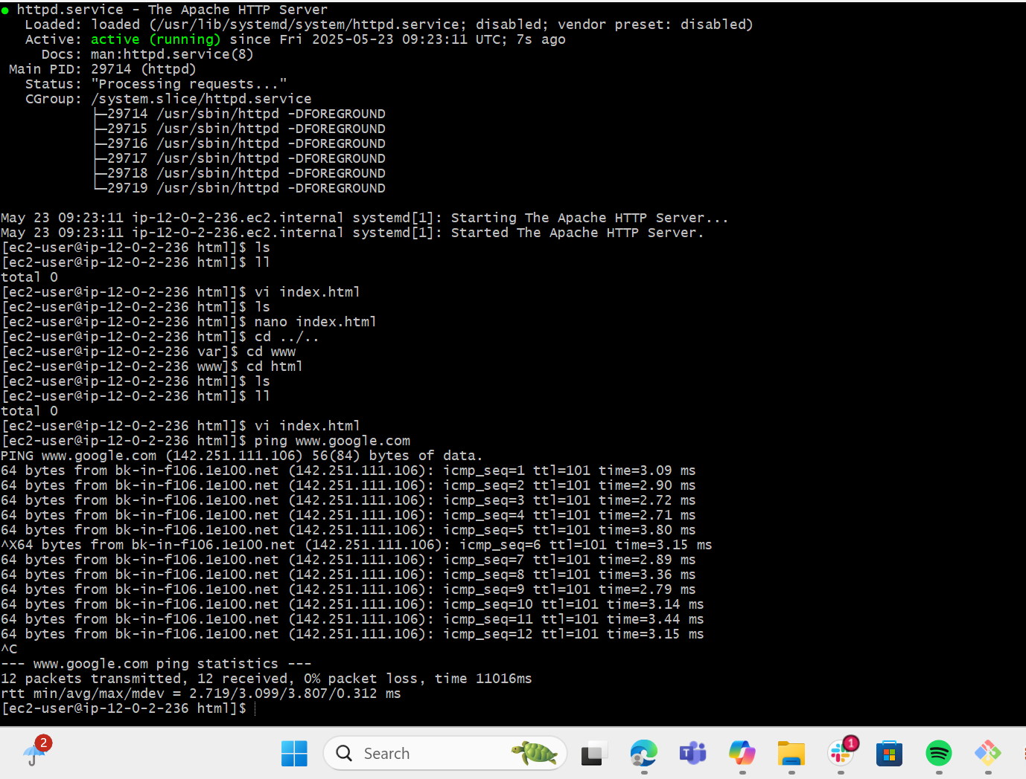

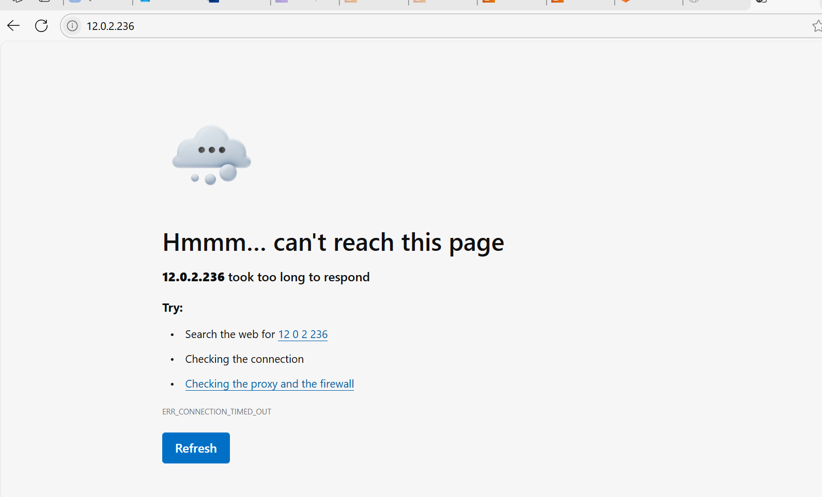

8) Create one application load balancer and attach the load balancer to both the ec2 instances

Go to Amazon console and select Load balancer service

Click on Create Load balancer

Select Application Load balancer and click on create

Enter Load balancer name as ALB-ASG

Scheme internet facing

Ip address type as IPv4

Select VPC which created and select atleast 2 availabilty zones and their subnets

Come to Listeners and rules

Select the Listener protocol HTTP and port 80

Now it will ask to select the Default action to select the Traget group

Create once Target Group

Provide Target group name and select the required detailes as VPC and remaining

Now come to Register Targets select the available instances of Public and Private servers

Once successfully created the target group

Now come Load balancer page select the target group created

Check the summary and click on create Load Balancer

Once the Load balancer provisioned successfully need to add rule in Actions

Once it is configured successfully check the health status of the Instances.

Try access with DNS of Load balancer , Now you will be successfully seen the sample index.html page which we deployed in Public and Private servers

This way we have successfully attached the instances to Load balancer

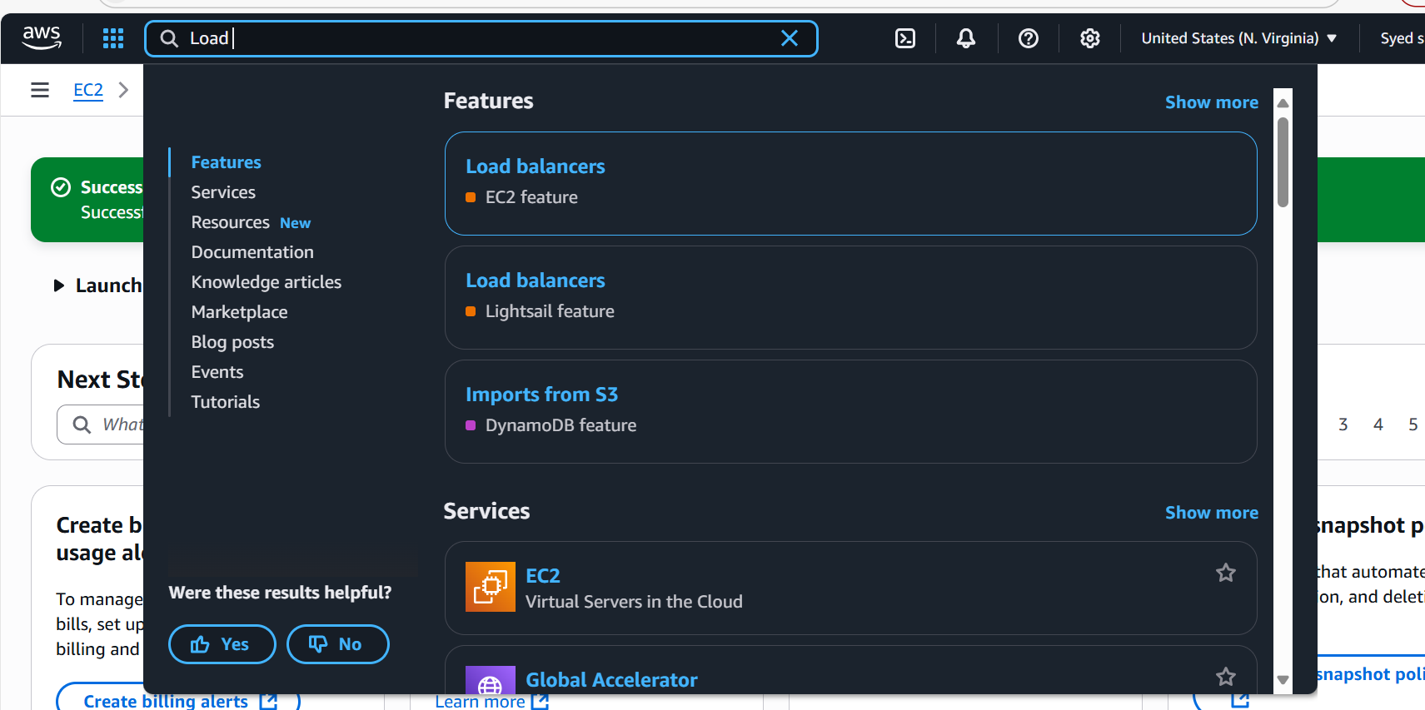

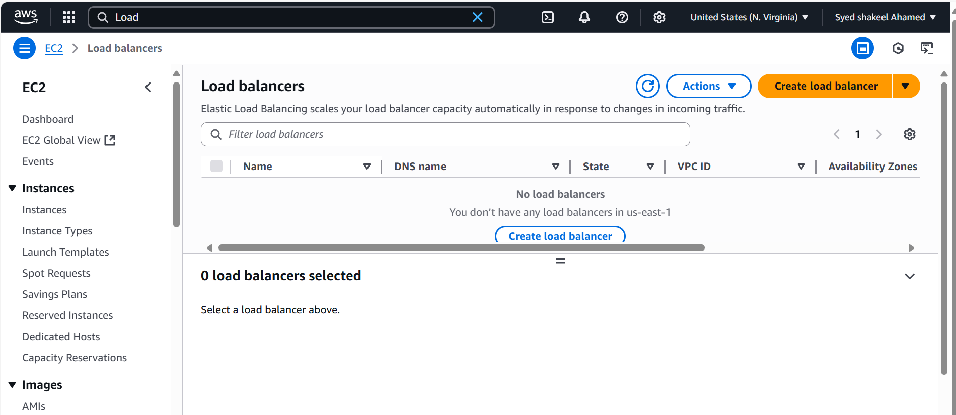

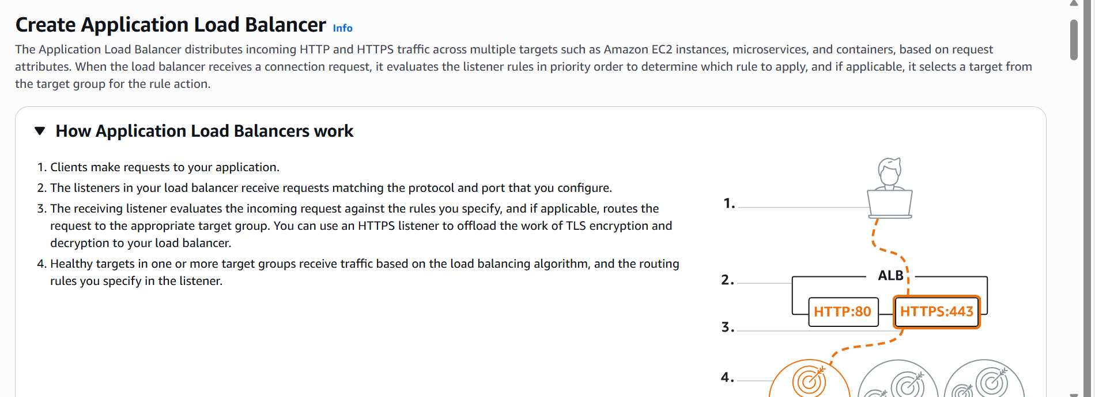

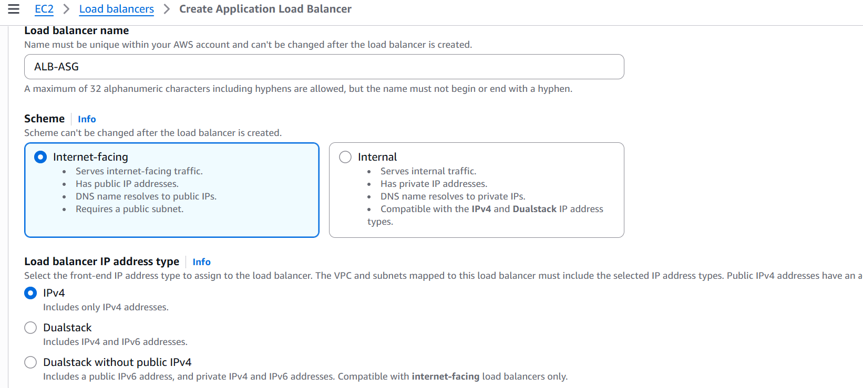

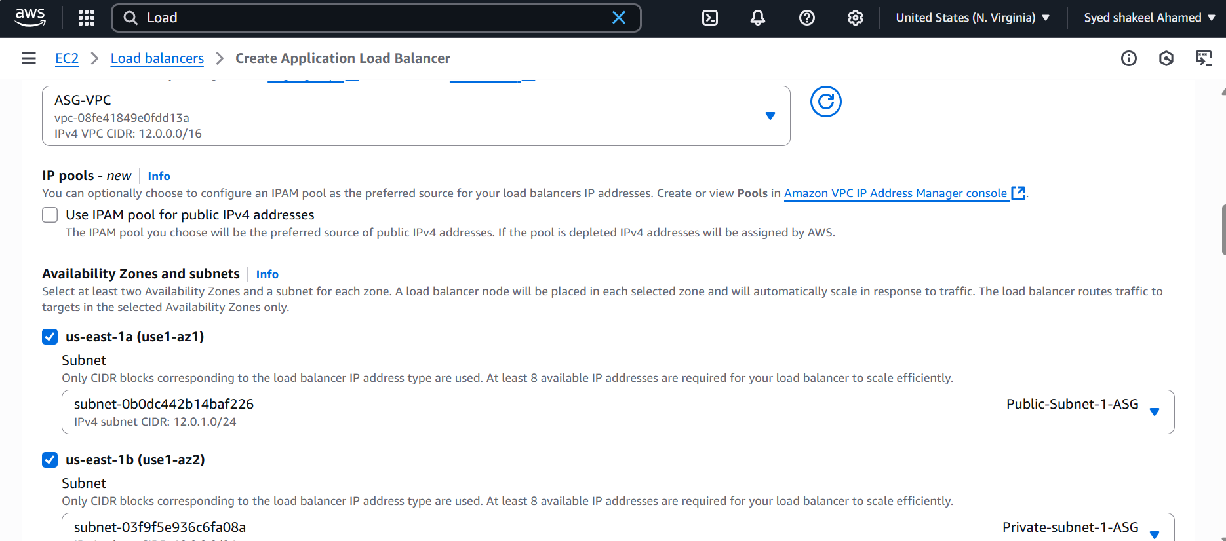

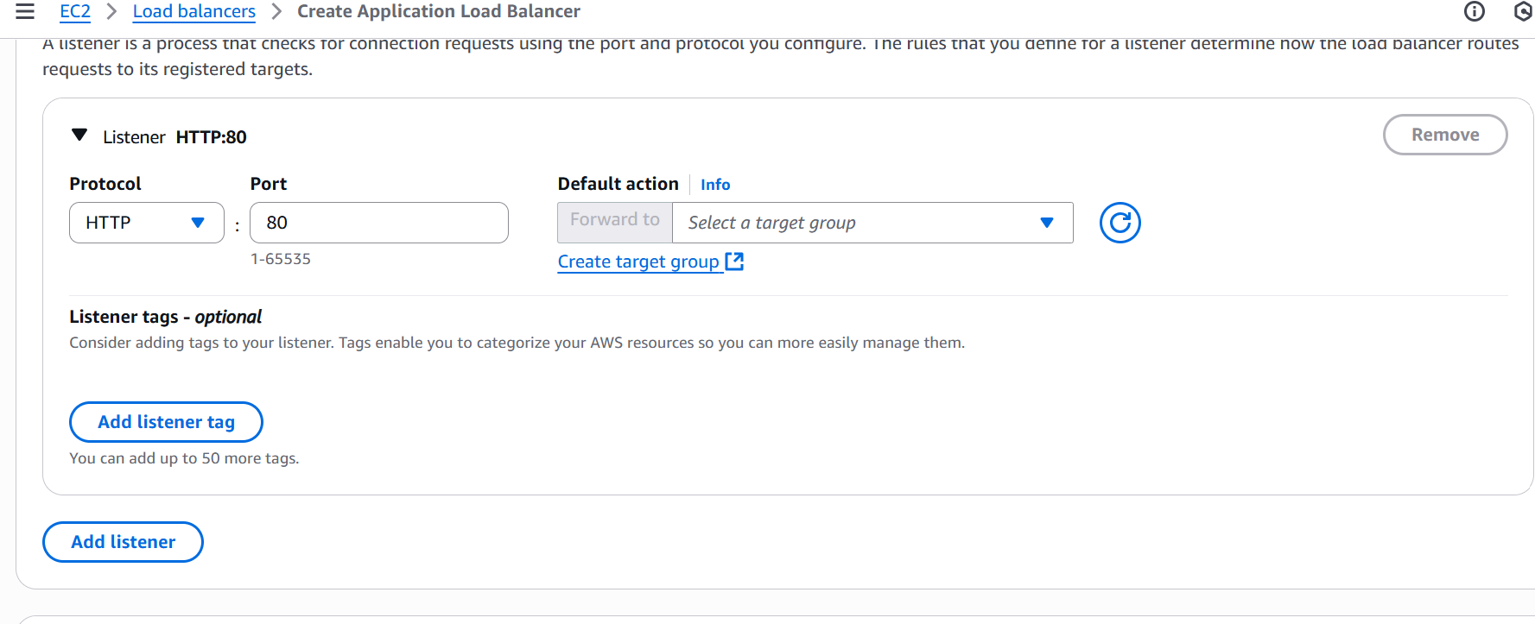

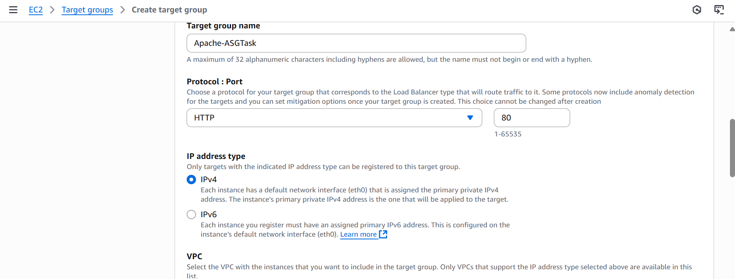

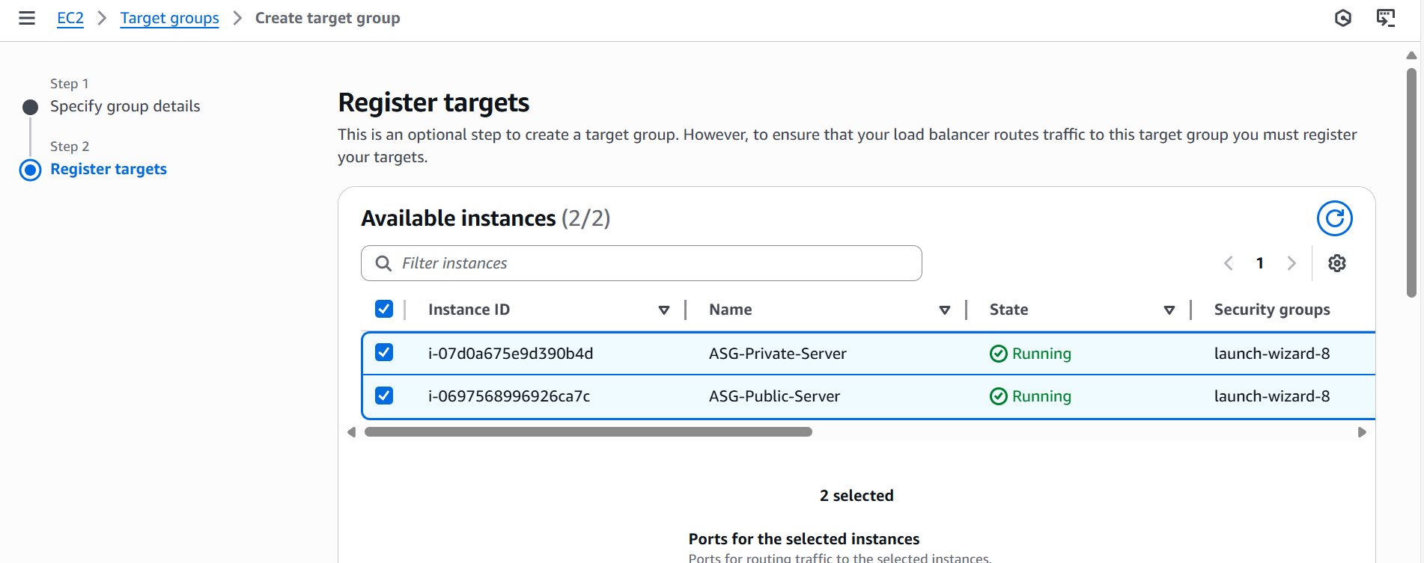

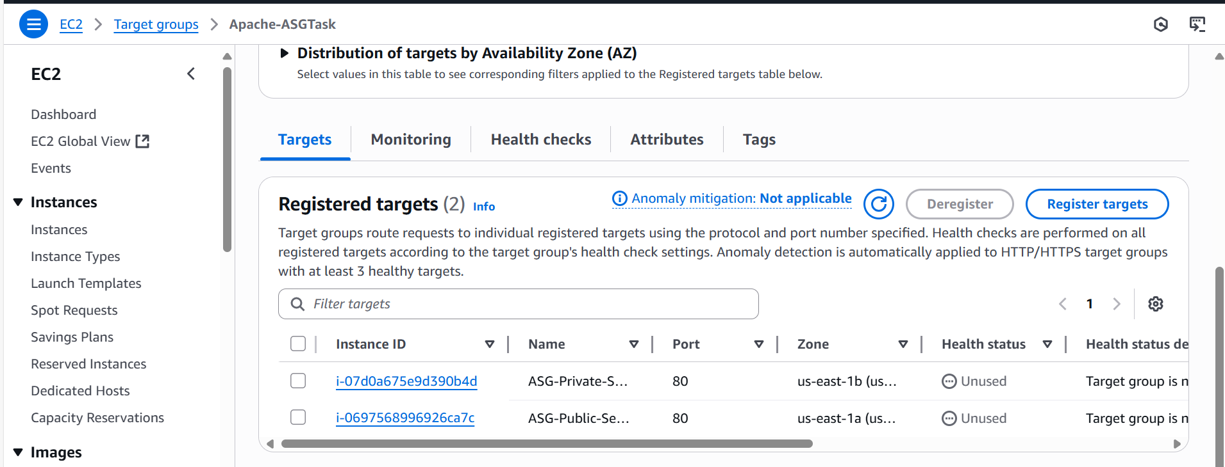

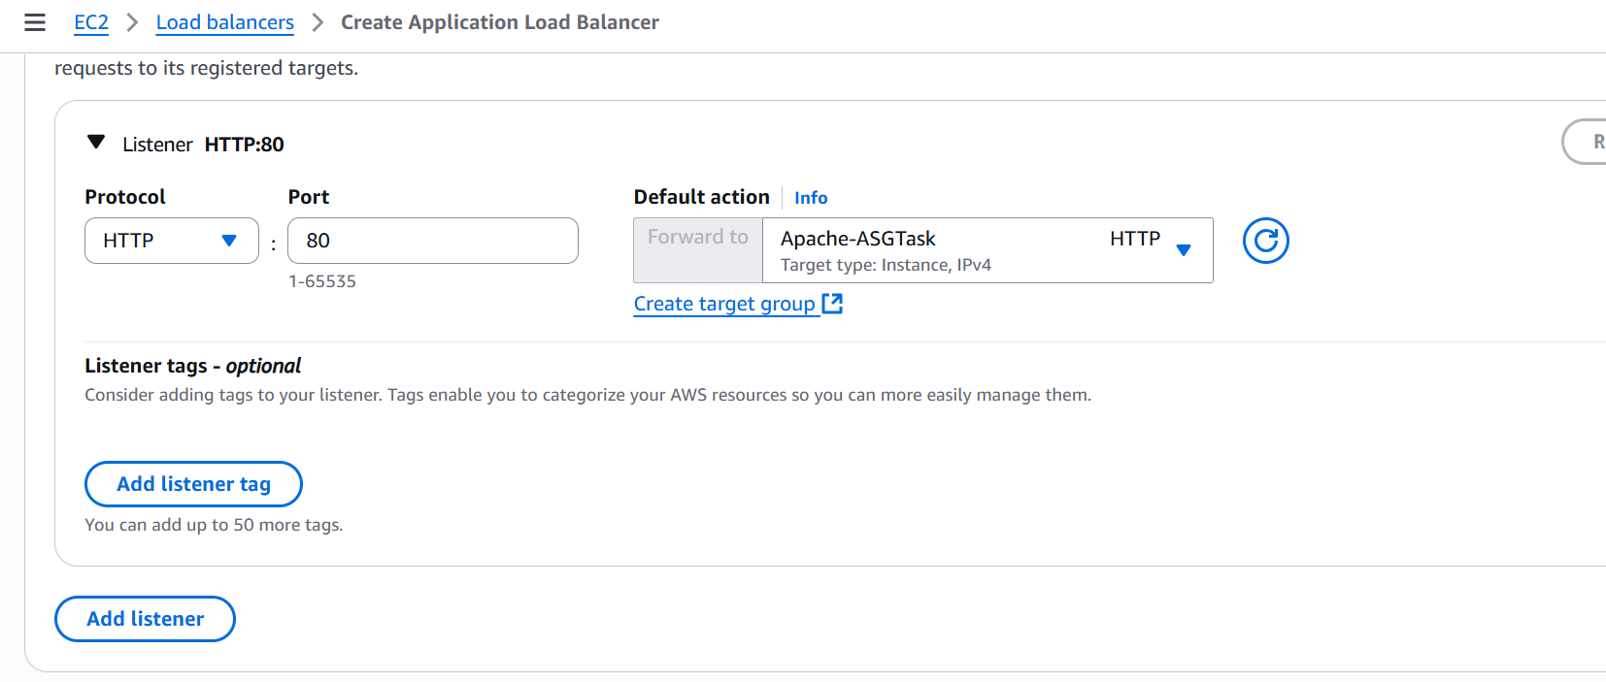

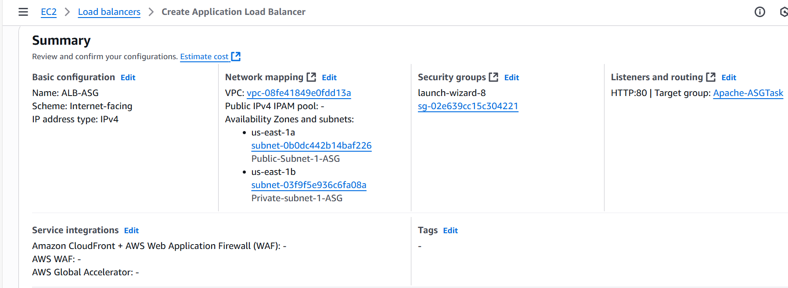

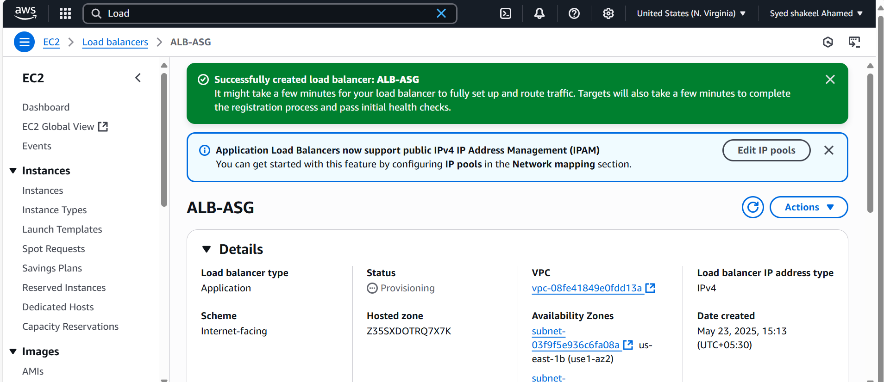

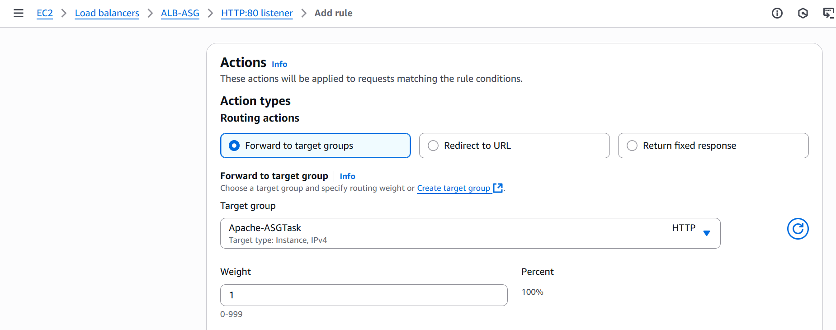

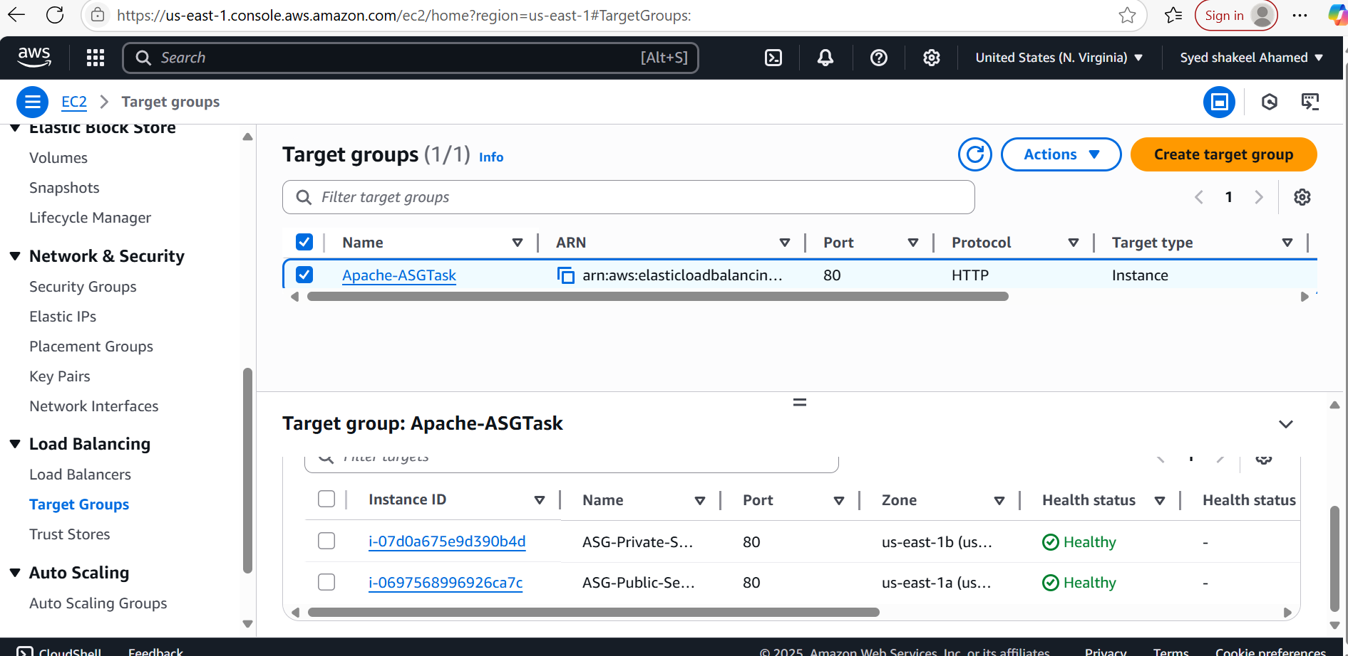

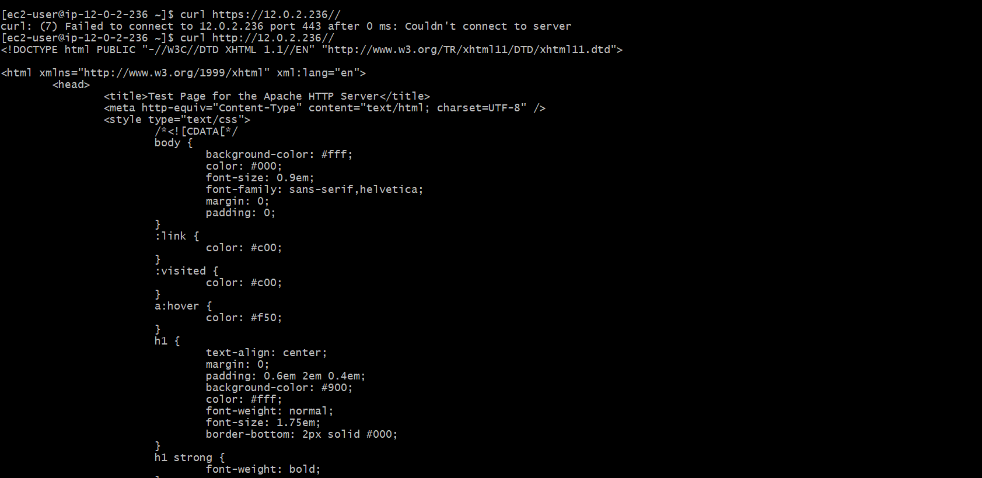

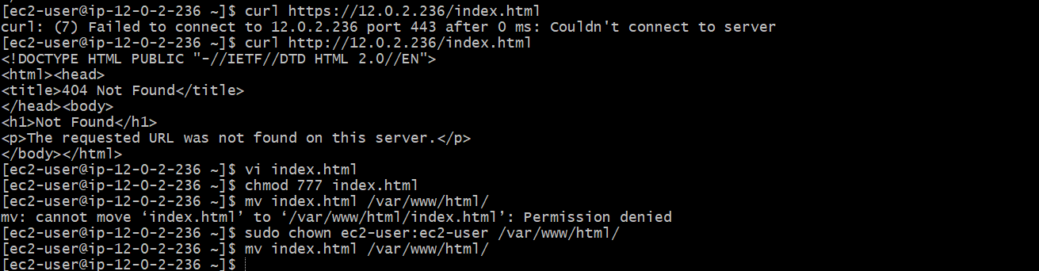

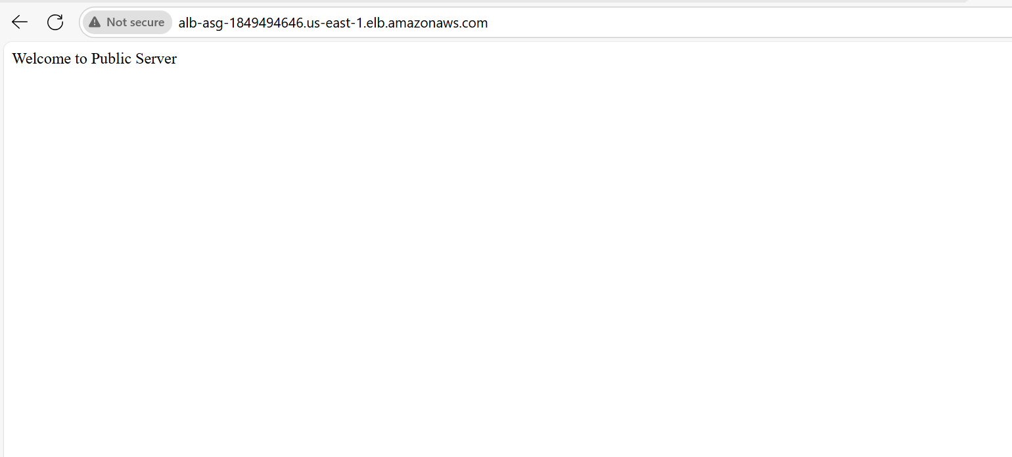



9) Store Application load balancer logs to s3

Create an S3 Bucket for Logs

- Go to AWS S3 Console → Amazon S3

- Click "Create Bucket" → Name it alb-logs-bucket

- Select AWS Region → Must match the ALB’s region.

- Enable Server-Side Encryption → Choose SSE-S3 for security.

- Click "Create Bucket" → Bucket is now ready.

Attach a Bucket Policy for ALB Logging

- Go to S3 Bucket Settings → Select alb-logs-bucket

- Click "Permissions" → "Bucket Policy"

- Add the following policy:

{

"Version": "2012-10-17",

"Statement": [

{

"Effect": "Allow",

"Principal": {

"Service": "logdelivery.elb.amazonaws.com"

},

"Action": "s3:PutObject",

"Resource": "arn:aws:s3:::alb-logs-bucket/AWSLogs/ACCOUNT_ID/*",

"Condition": {

"StringEquals": {

"s3:x-amz-acl": "bucket-owner-full-control"

}

}

}

]

}

Replace ACCOUNT_ID → Use your AWS account ID.

- Click "Save" → ALB now has permission to write logs.

Enable ALB Access Logging

- Go to AWS Load Balancer Console → Elastic Load Balancing

- Select Your ALB → Click "Edit Attributes"

- Enable Access Logs → Toggle ON

- Enter S3 Bucket Name → alb-logs-bucket

- Set Log Prefix → Example: AWSLogs

- Click "Save Changes" → Logging is now enabled.

Verify Logs in S3

- Go to S3 Console → Open alb-logs-bucket

- Navigate to AWSLogs/ACCOUNT_ID/elasticloadbalancing/REGION/

- Check for Log Files → Logs should appear within minutes.

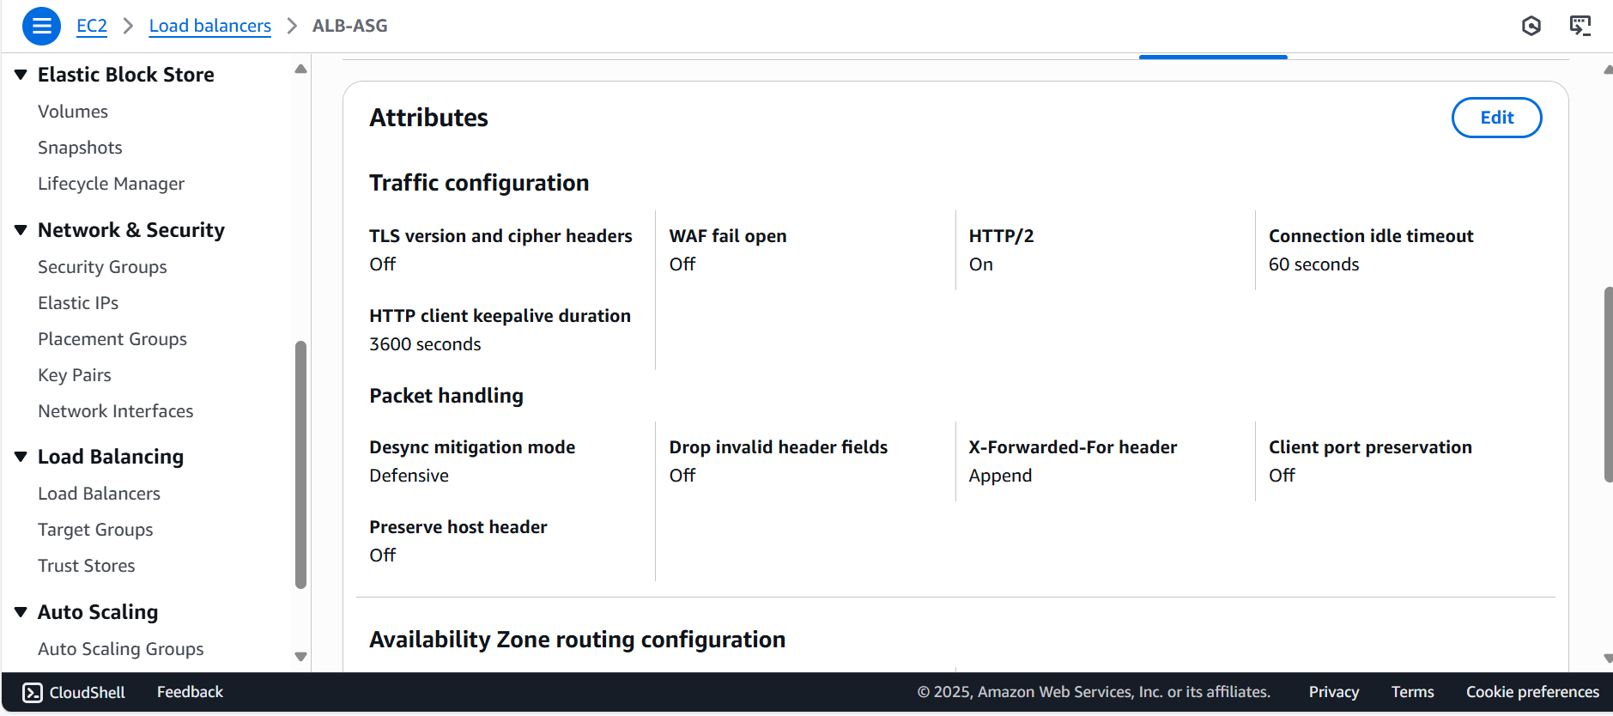

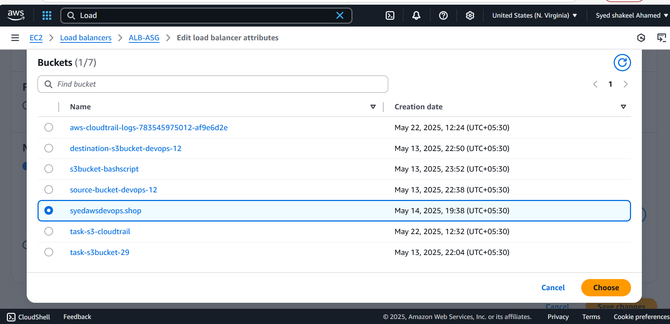

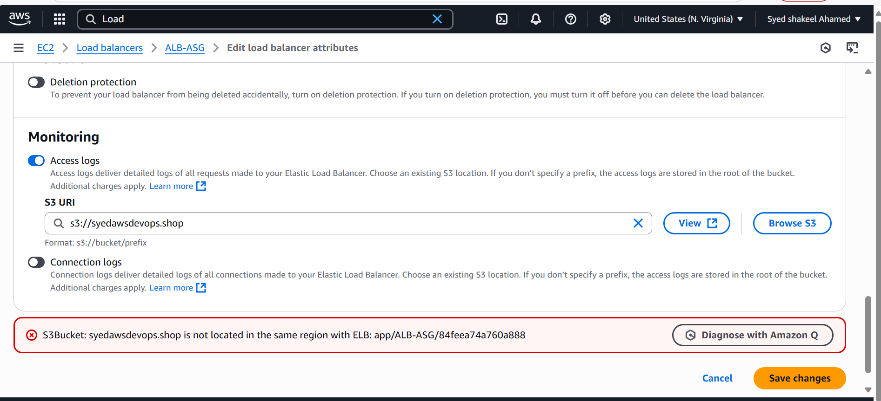

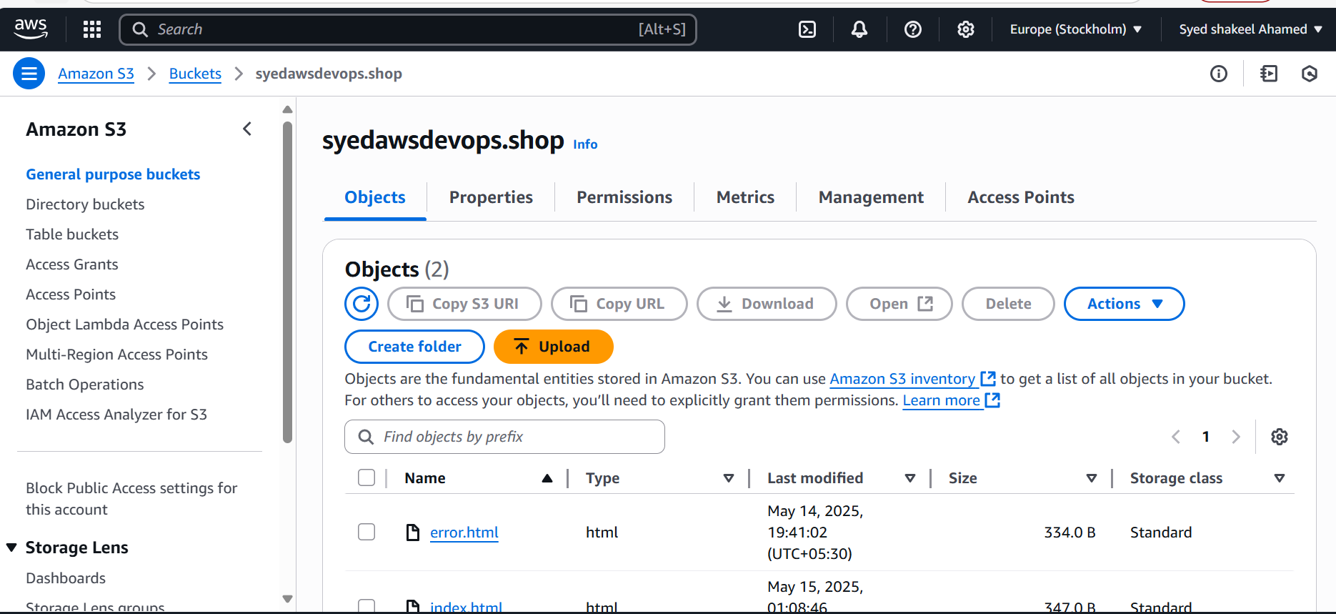

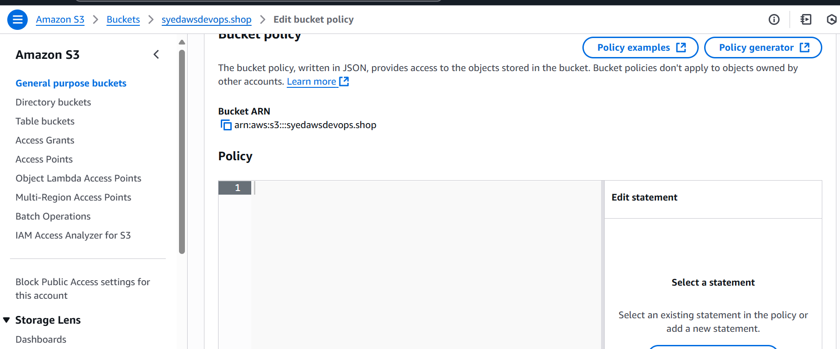

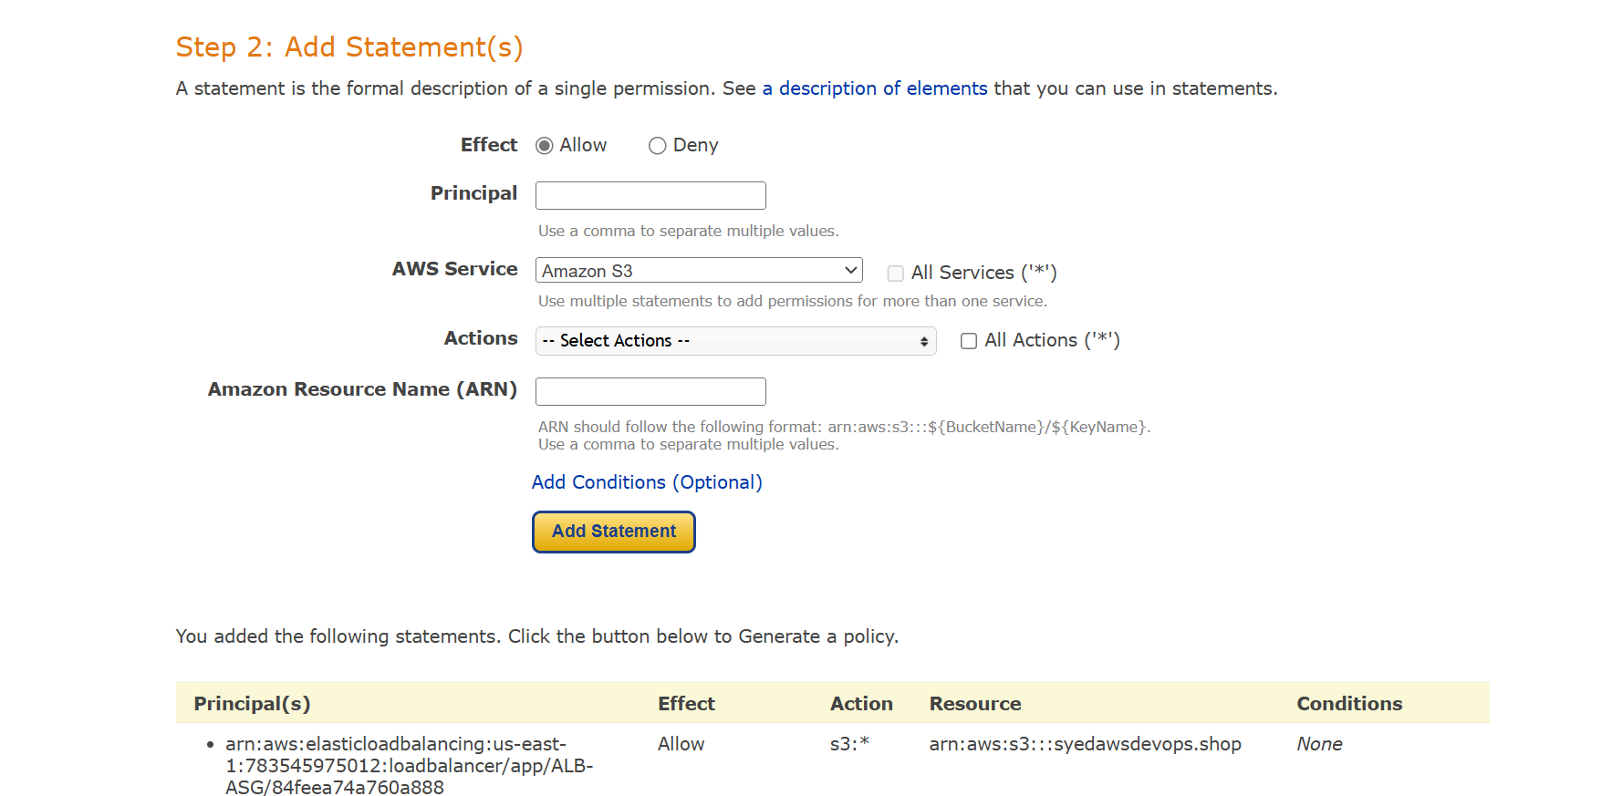

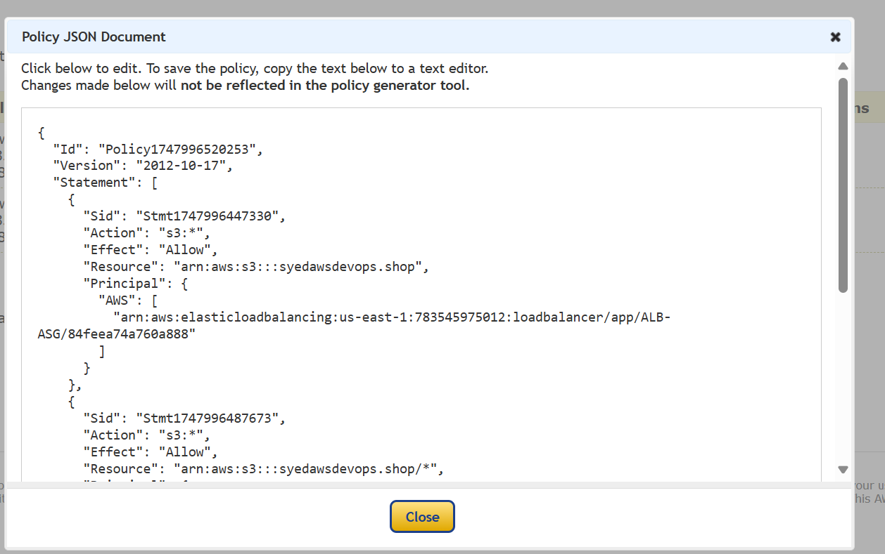

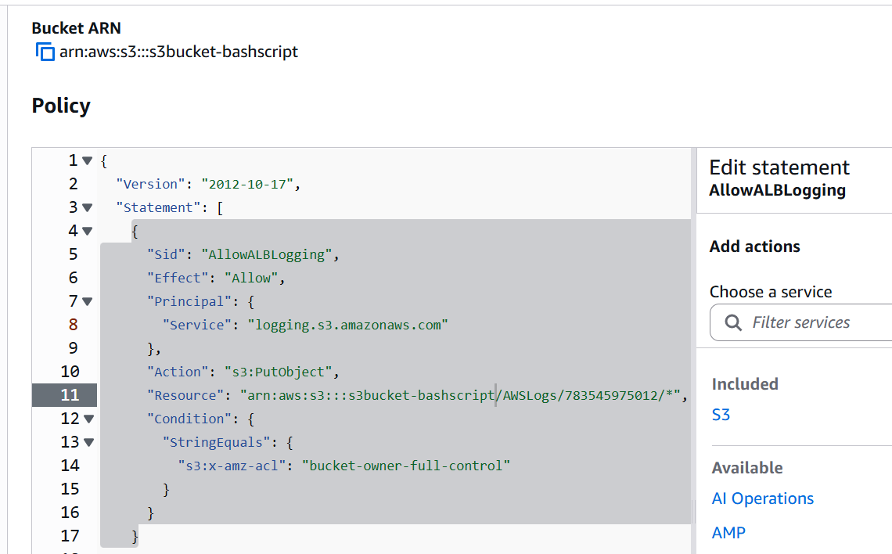

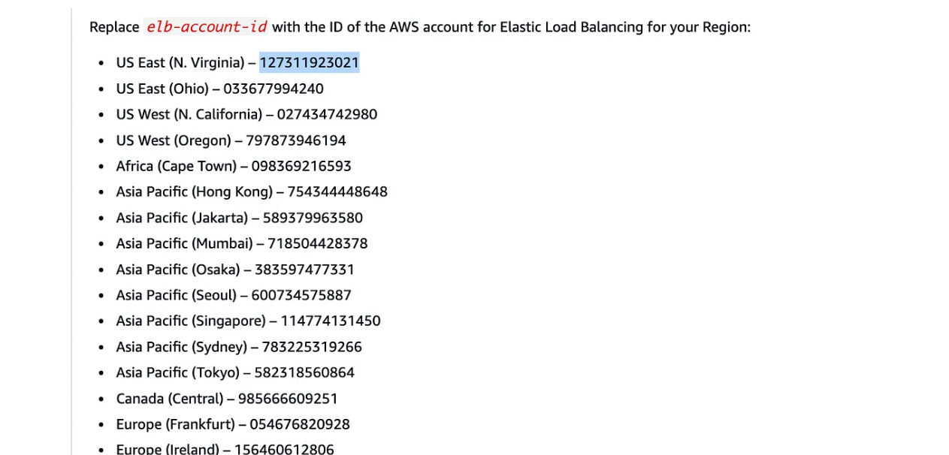

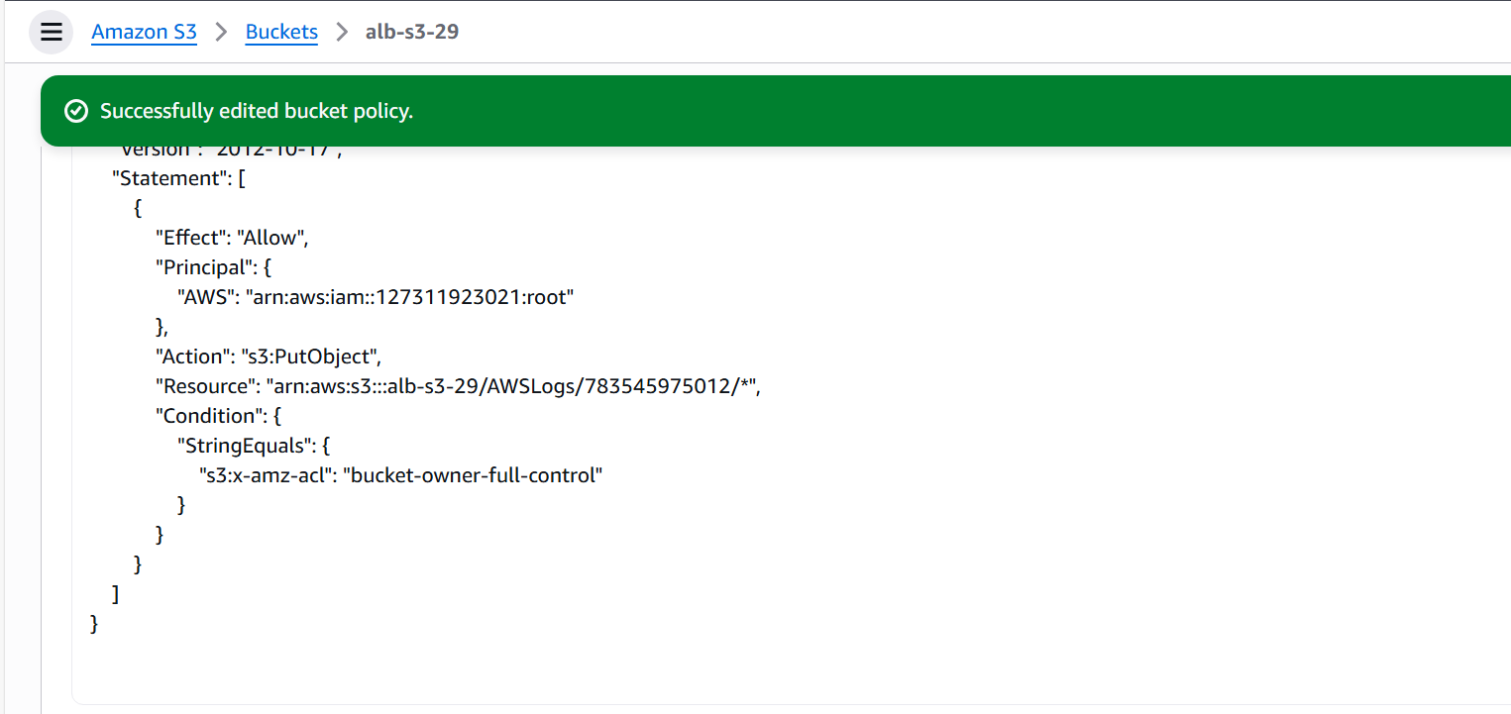

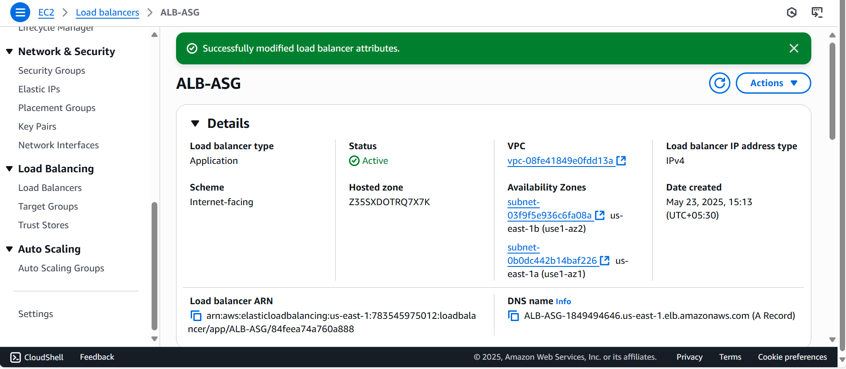

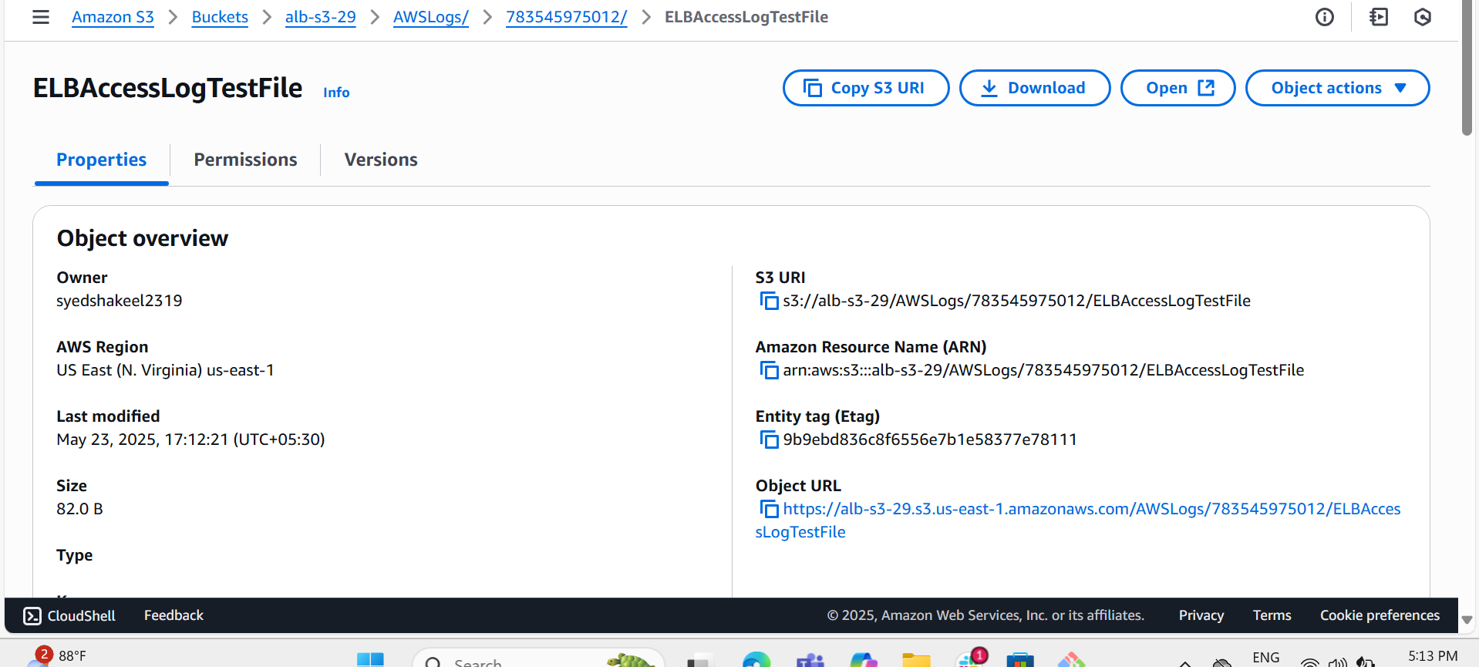

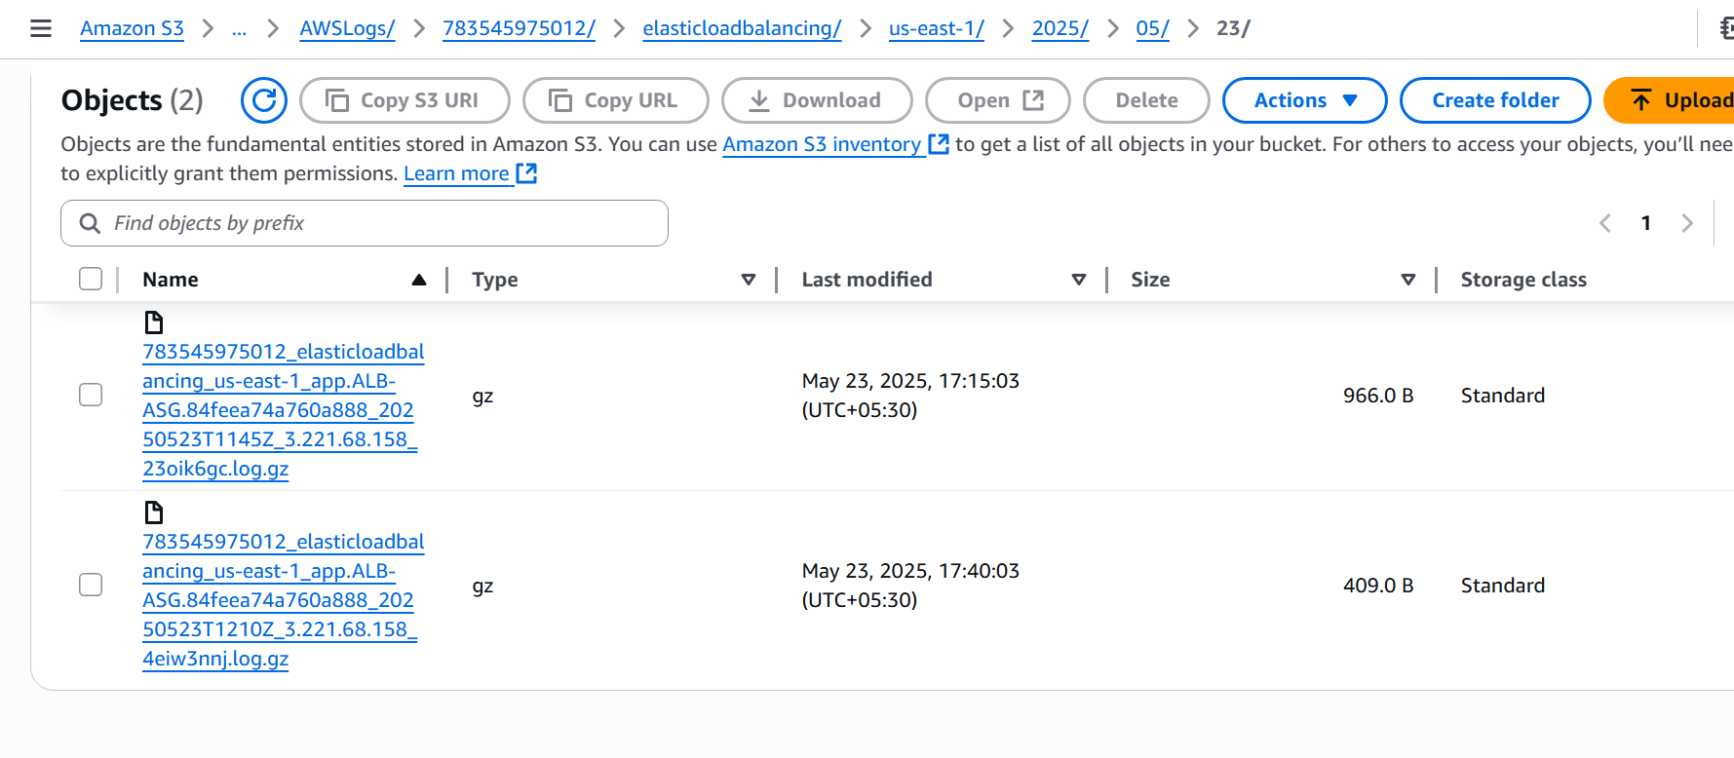

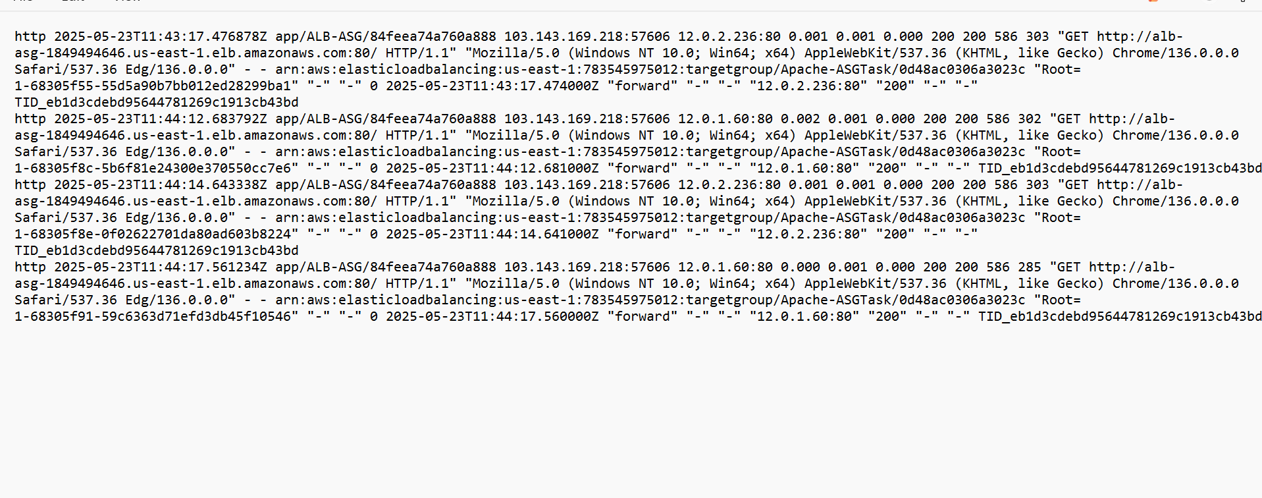

10) Store the vpc flow logs to cloudwatch group

Go to EC2 instances Dashboard

Go to VPC Dashboard

Select the VPC which we have created already

In that select Flowlogs option

Click on Create Flowlogs

Enter the name of your VPC flowlogs

select Filter to accept all requests

Maximum Aggregation interval time select 1 minute

Destination Send to Cloudwatch logs

Now create IAM role to send the VPC flowlogs to Cloudwatch logs

Select the existing IAM role created

Click on the create Flow logs and created successfully

Now go to Cloudwatch Logs

check the logs for VPC flowlogs created

Try to modify or do some changes with your instance and you can see the log events created successfully

So this way we can successfully push the VPC flowlogs to Cloudwatch

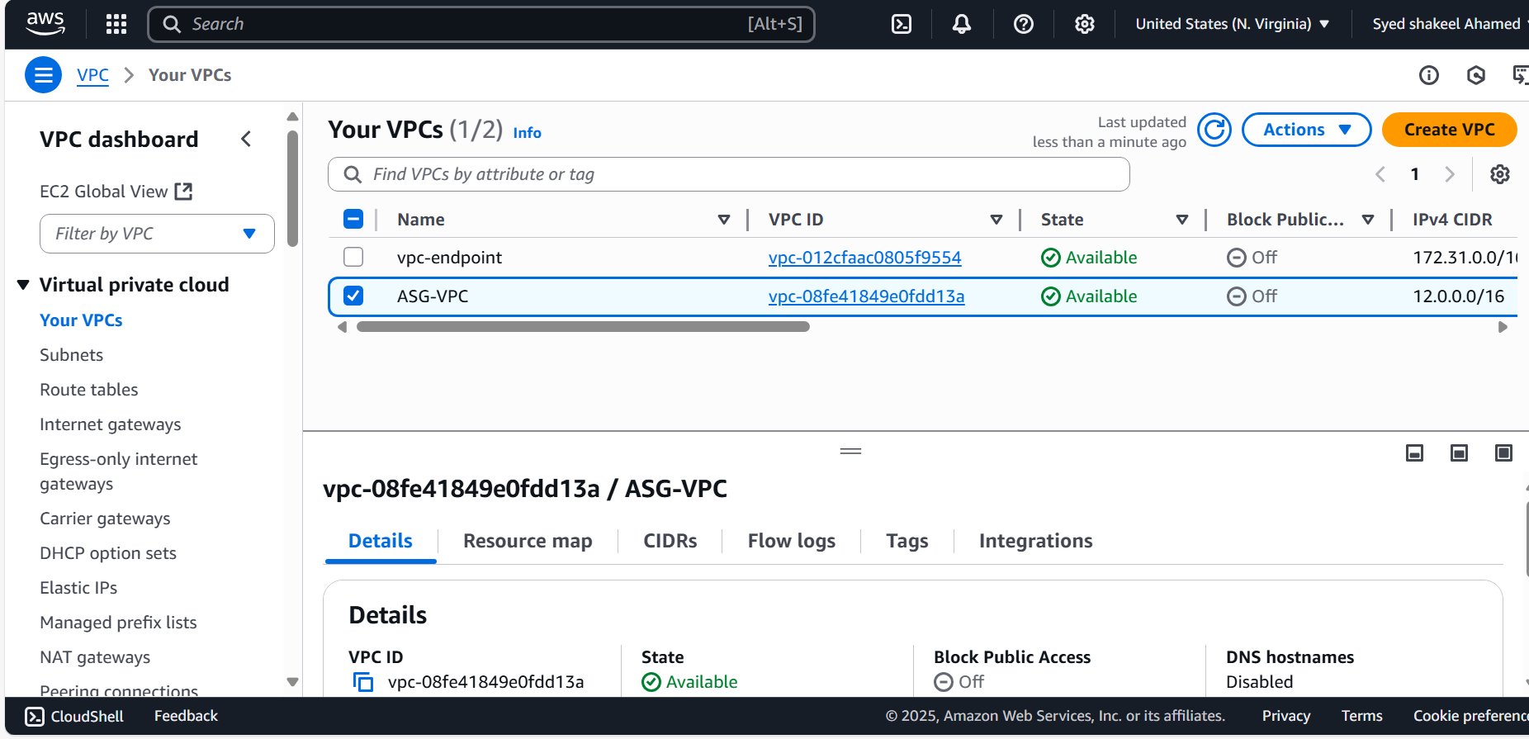

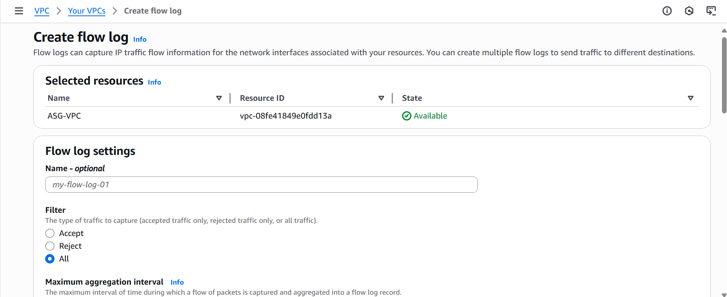

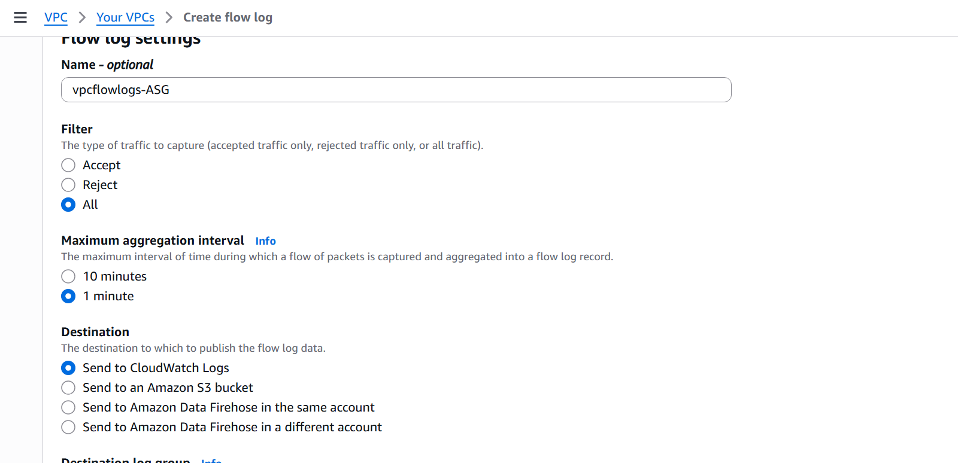

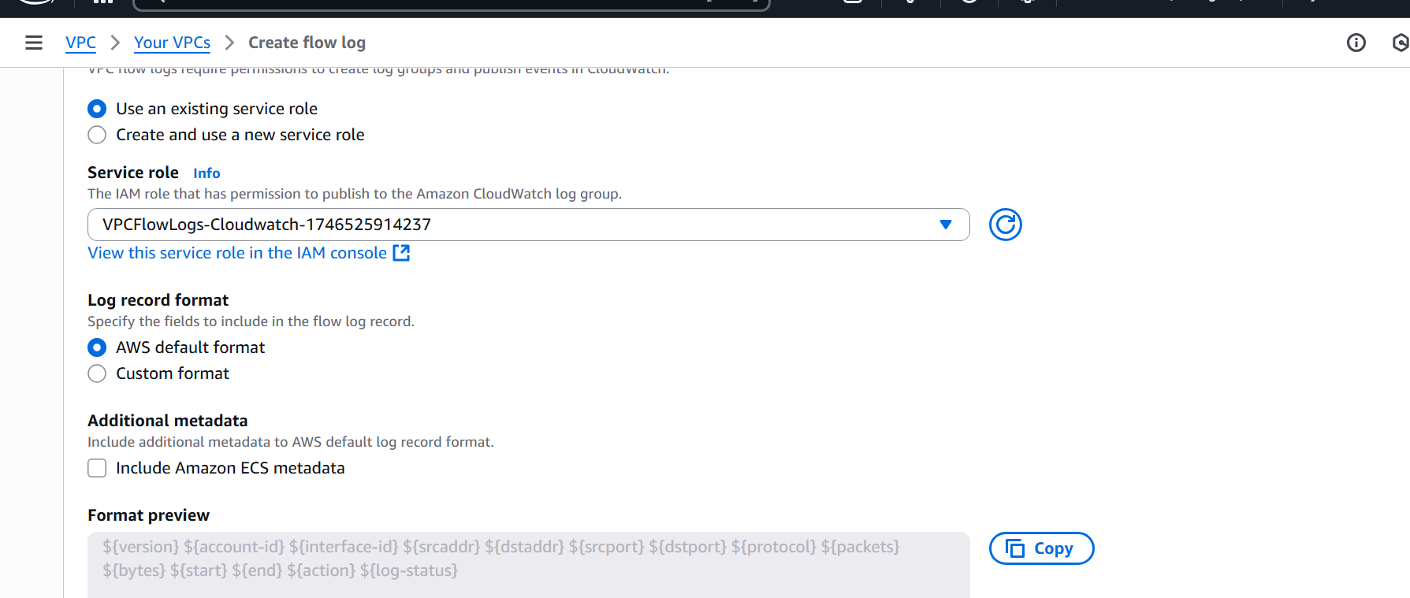

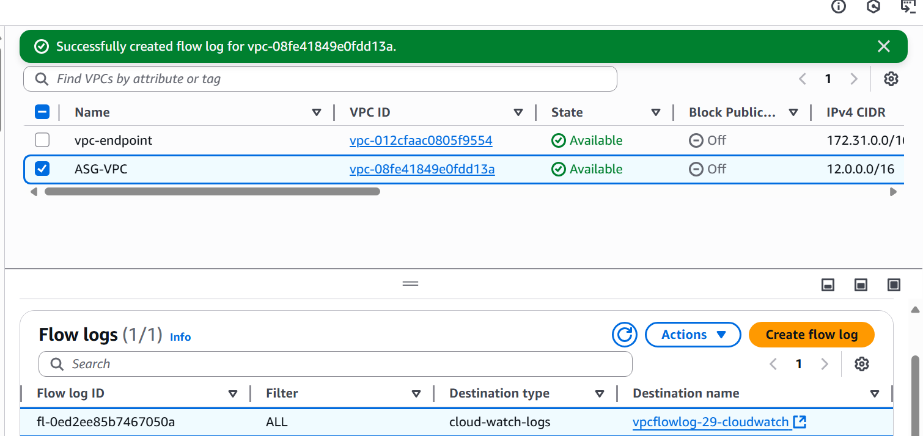

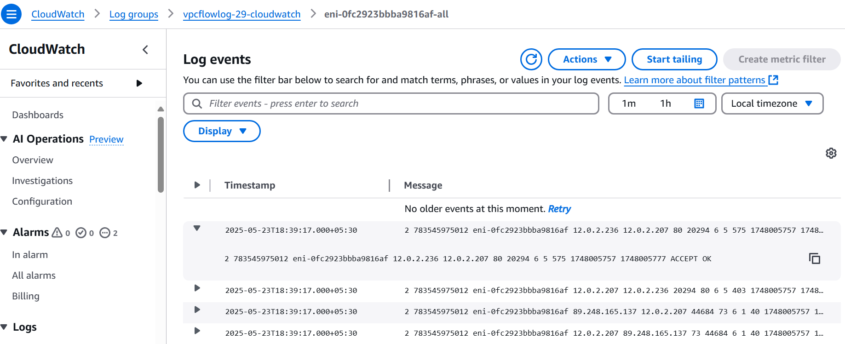

11) Create Monitoring Dashboards to monitor CPU utilization and to monitor Apache service

Select the instance for example Public Server in which already Apache is deployed

And Go to Detailed Monitoring and enable it

Now select the CPU utilization metric

check for the Graph

Add some fake load to CPU by using yes >/dev/null &

Go to Cloudwatch Dashboard create a new dashboard name CPU utilization

Select the Widget , number and next select Metric EC2 Pre-instance

Search with your instance id and select the metric type as CPU Utilization

Create widget

After this you can check regularly what is the CPU utilization for this instance by refreshing in certain time intervals like 1 minute

Now repeat the same procedure for Apache service monitoring

Either you can monitor using Request count or Network in

Create the dashboard in Cloudwatch and monitor the same procedure as we have done in the CPU utilization

This way we can do the real time monitoring of our instance using CPU utilization and service monitoring

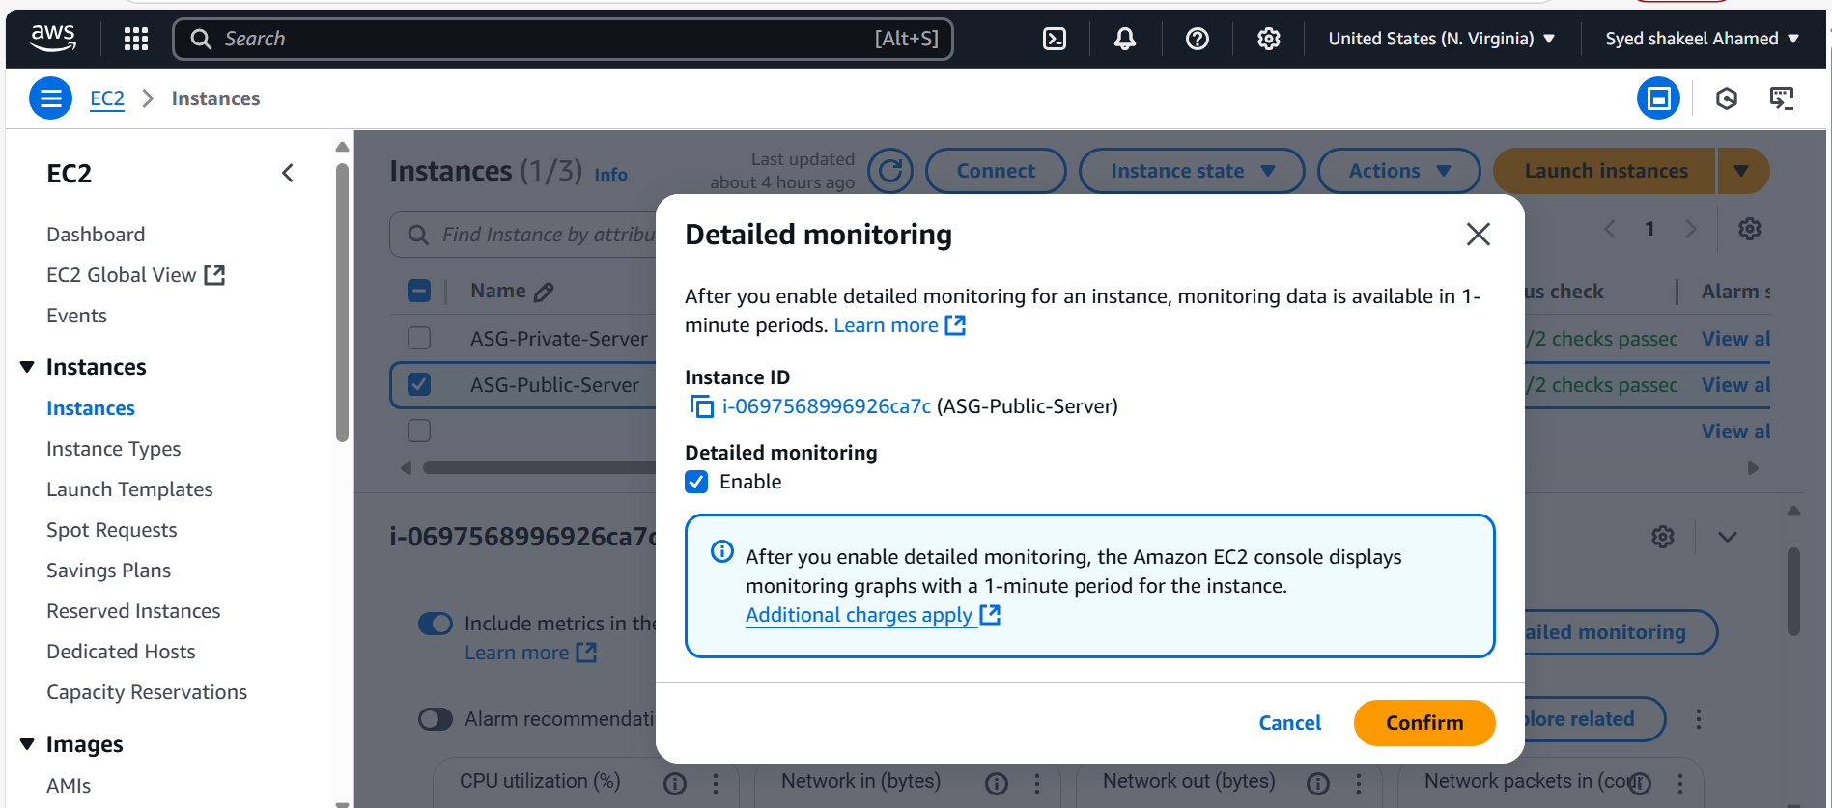

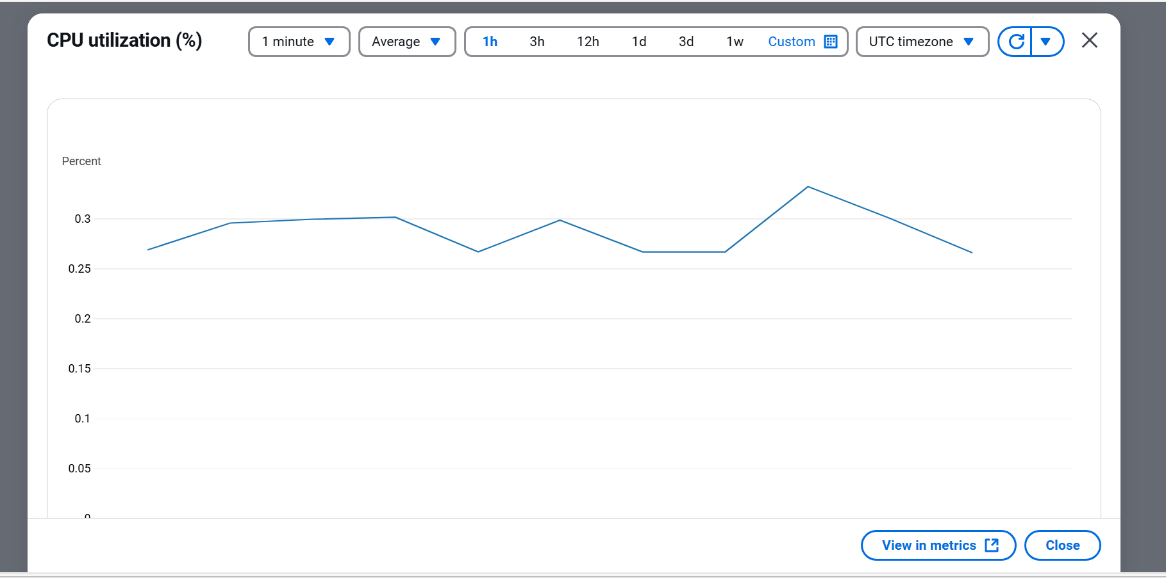

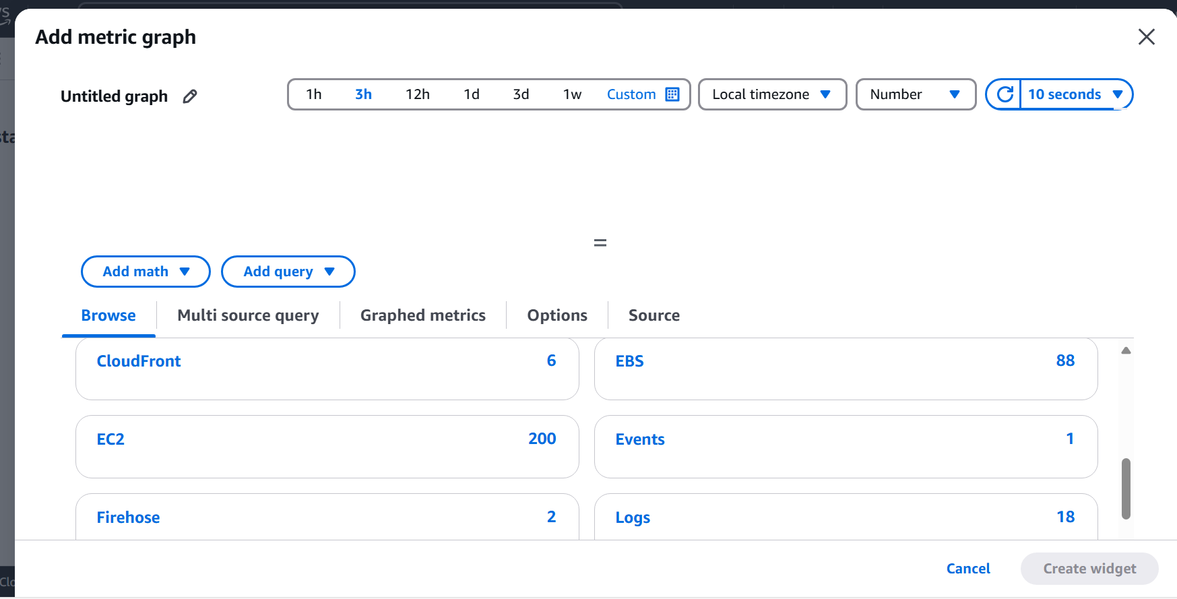

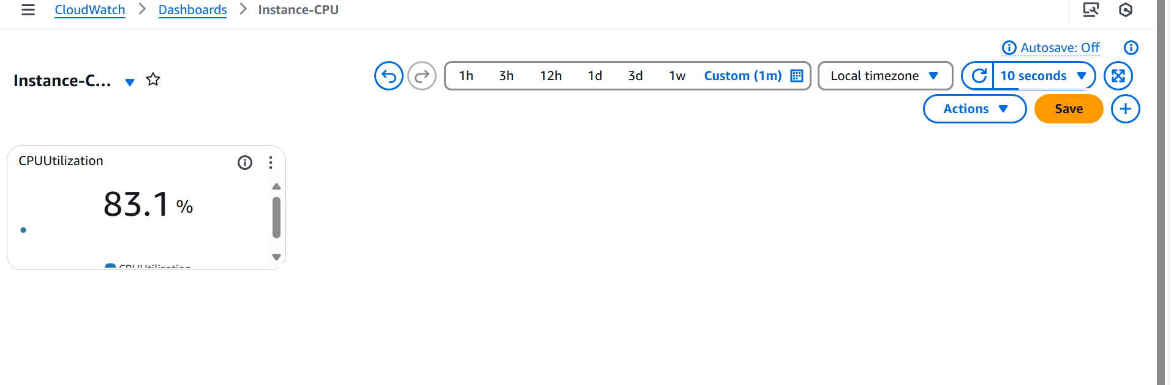

Apache Service Monitor Cloudwatch Dashboard

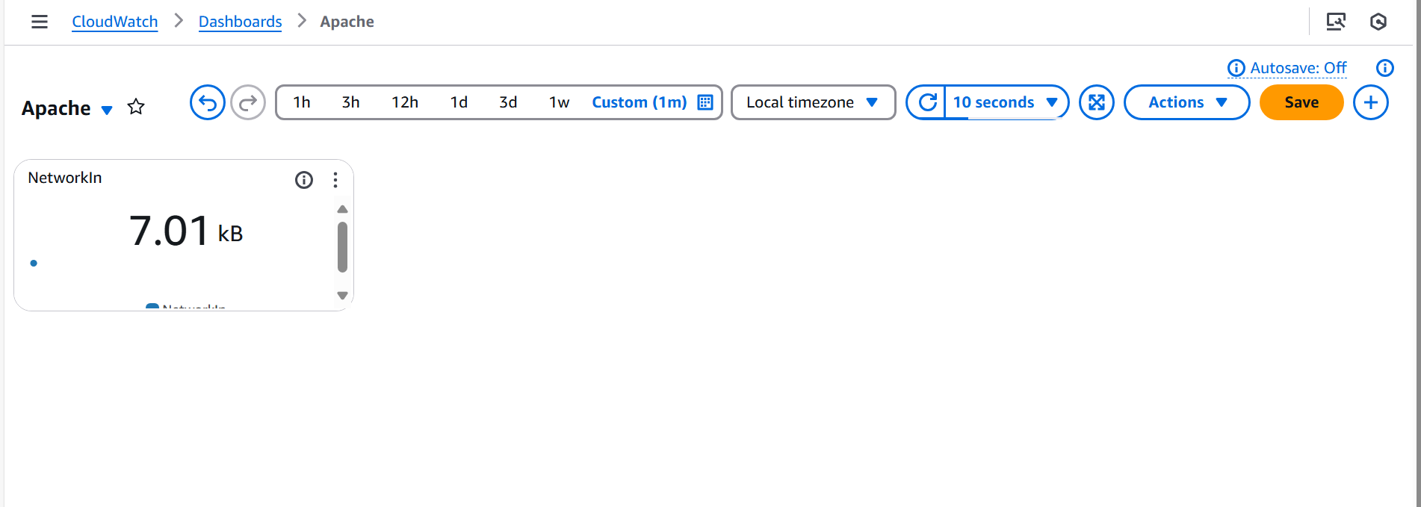

12) CPU utilization is more than 70% then it should trigger Autoscaling and launch new instance.

Go to Ec2 instances

Select Launch Templates and click on Create Launch Templates

Enter the name and remaining details like AMI, instance type,Keypair

In network setting select the Public Subnet and select exisiting security groups

Now click on create Launch Templates

Successfully Launch Template created

After this Go to Autoscaling Groups

click on Create Autocaling Groups

Enter the name and select Launch template which created already

Select VPC and availability zones and subnets

Next attach existing Application Load balancer which was created already

Select the exisiting Target Group

Now select the Group size as Desired 2 , minimum 1 and Maximum 5

Select the Scaling Policies Target Tracking scaling Policy

Select CPU Utilization in metric type

Target value 70

Now click on create Autoscaling Group and it is successfully created

Go to Cloudwatch dashboard and check the metric of instance EC2 Cpu utilization

If it is more than 70% then automatically the instance will be launched in EC2 dashboard

Verify this in EC2 dashboard.

